Ellis Atchison
ECE 4220 Real Time Computing
G.DeSouza
12/18/09
Smart Phones and Ubiquitous Computing
Background of Ubiquitous Computing
Ubiquity is defined as existence or apparent existence everywhere at the same time. The field of ubiquitous computing was first described by Mark Weiser in 1988. His vision for ubiquitous computing was making computers available throughout the physical environment, while making them effectively invisible to the user, so that the power of computing is seamlessly integrated into the user’s life. In his own words, the goal of ubiquitous computing is “to make computers an embedded, natural and fitting part of our lives so that we use them without even thinking about it” [1].
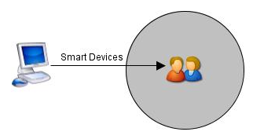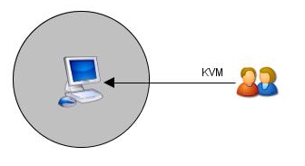
Figure 1: Ubiquitous Computing Model Figure 2: Present human computer interaction
Figure 1(above) shows the ultimate goal of ubiquitous computing, where processing and computing power are brought into the user’s world by way of smart devices. In the future, smart devices will be the gateway to computing power. This is in contrast to the present model for computing, shown in Figure 2 (above right), in which users must effectively enter into the world of computing by means of keyboard, video, and mouse. So the current model and means of computing, which bases human computer interaction on KVM, will be replaced entirely by smart devices in the future. In his article “Open House”, Weiser suggests many smart devices such as smart clothes that know when they need to be washed, smart pens that can digitize everything we write, and smart alarm clocks that know our schedules and wake us up accordingly [2].

Challenges Presented by the Ubiquitous Computing Model
A main challenge of realizing the ubiquitous computing model concerns these smart devices: how will we interface with them in a non-intrusive way? Another challenge is the networking of smart devices to form smart environments. Will these devices communicate with each other or a mainframe within the environment? Also, what technologies will be used to network smart devices?

Smart Phones and the Advancement of Ubiquitous Computing
Because of the popularity of the iPhone, society is shifting and accepting smart phones as mainstream where once they were only for the business elite. Everyday people are now accepting the technology of the smart phone and incorporating into their lives. In the past, the phone just provided a link between you and whoever you wanted to call, but with today’s smart phones and all their options, such as internet capabilities, they are much more. Smart phones and similar devices provide the user with an internet link, through which they have access to almost anything they could need such as directions to the nearest restaurant, weather updates, sports scores, and much more. Because today’s smart phones are so integrated into consumers lives, I propose they are the perfect avenue through which the ubiquitous computing model could be advanced.

Smart Phones as Interface to Smart Environments
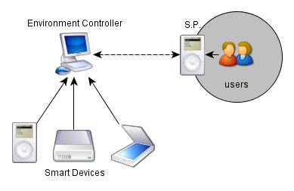
Figure 4: Smart phone as interface to static smart environments
Smart phones solve the challenge of how to interface with smart devices in a static smart environment, in which the smart devices are stationary. While the smart phone doesn’t meet the theoretical goal of completely non-intrusive interfacing, it’s a huge step in the right direction. Using the convenience of the smart phone, users can easily interact with smart devices in the environment around them. Whether by keypad, touch screen, or voice commands, the smart phone can serve as the terminal for smart devices in the event the user needs to adjust the settings of a smart device or access it directly for other reasons. With the smart phone model presented in Figure 3, users can simply walk into a smart environment, such as the smart home for example, and their smart phones can talk to the environment controller to trigger interactions such as greetings from the environment, an adjustment of settings in the environment, etc. Additionally, interfacing with smart devices from the smart phone doesn’t have to be a user engaging process. Take the smart home for example. The user can use his smart phone to predefine settings for the house under different conditions such as user at home, gone to work, etc. Then the smart phone takes over management of smart devices, which frees the user of active participation in the system. Therefore, the smart phone knows the user is about to go to work and schedules the house’s features such as blinds, temperature, electronic devices, etc. to automatically adjust to this condition of “user not home”. So the user goes to work and the blinds shut themselves, the temperature settings are adjusted to conserve energy, and electronics such as the lights, television and computer are shut down as well. The smart phone is critical in this process because without it, these tasks are simply scheduled by the user at a terminal and the process is rigid rather than ubiquitous. With the smart phone model, if the user is late to work, smart devices on their clothes can detect this through biometric sensors (elevated heartbeat and perspiration indicate the user is in a rush) and relay the data to the smart phone, which is monitoring these devices. Then the smart phone can adjust the smart house’s schedule to meet the user’s needs, all without the user having to formally interact with the smart phone. This prevents the lights from going out while he is rushing to dress or the computer from shutting down in the middle of a business critical email.

Smart Phones as the Mainframe of Smart Environments
Another challenge the smart phone can help to solve is the networking of smart devices in a dynamic smart environment, which is an environment in which the devices aren’t permanently located. Since smart devices are small, power consumption is an issue. Therefore, these devices have a limited range regarding their wireless communications. So if you have a large environment, a smart football field for example, it would be hard for devices to communicate effectively over that distance for a sustainable period given the limited amount of power available. So there is a tradeoff between distance of communication and battery life of smart devices. This is where the smart phone can help because it has longer range capabilities.
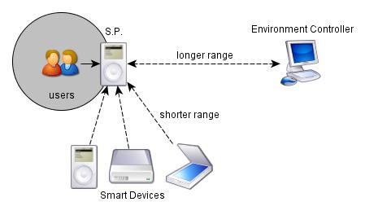
Figure 5: Smart Phones as a mainframe within smart environments
The smart devices within the environment can use short range technologies which conserve power, such as Bluetooth, ZigBee or RuBee, to talk to the smart phone. Then the smart phone can re-transmit that data to the smart environment controller to be processed using longer range communication such as WiFi, WiMAX, or 3G/GSM/CDMA. To expound upon the smart football field example, the field and the ball can be imbedded with smart devices as well as the players’ equipment, especially the knee pads, all of which work together to keep track of ball positioning, specifically working to accurately define where the ball is when the player is ‘downed’. Since the devices would be limited in range, they couldn’t communicate directly with the environment controller, potentially located hundreds of feet away in the officiating booth. In this situation, the smart phone could be utilized. The referee could have the smart phone in his pocket, and then when he goes into the dog pile to retrieve the ball at the end of a play, the smart devices on the field, ball, and players all relay data to the smart phone, which relays that data to the booth to be processed. After processing, the results are sent back to the smart phone and the official can see the correct spotting for the ball.
Conclusion
In conclusion, realizing the ubiquitous computing model is still more of a fantasy than a reality. Since the end goal of ubiquitous computing is making computers completely human-centric, much work needs to be done to develop new technologies in the area of human computer interaction. It would seem fitting that in a completely ubiquitous world, computers would be able to effectively interpret our brainwaves as to read our thoughts and desires, which would completely eliminate the need for terminal and device based computing. Since this isn’t a current possibility, how do we advance the ubiquitous computing model? I propose smart phone is the solution. As outlined above, smart environments can be created to utilize the power of the smart phone while also limiting computer-centric interaction with the environment by the user. Since smart phones are already equipped with microphones, cameras, and wireless capabilities, utilizing them within smart environments is simply a matter of interoperability with specific smart devices. Therefore, to achieve some of the visions presented in this paper such as the smart house or smart football field, mainly programming needs to be done. The hardware tools needed to achieve these visions are already available in smart phones: powerful processors and wireless networking capabilities. Furthermore, more and more people are getting them so they are widely available. They hold personal information, are always carried with the user, and are already our main way of communication. Therefore, I propose that implementing the smart phone within smart environments, either as an interface as presented in Figure 3 or a mainframe as presented in Figure 4 just makes sense.

References
[1] http://www.ubiq.com/hypertext/weiser/UbiHome.html
[2] http://www.ubiq.com/hypertext/weiser/wholehouse.doc

