Joe Hitt
08369507
The ISO OSI and 3G Networks

The International Organization for Standardization ( ISO ) has been around for over 60 years setting up standard protocols so that they will be common throughout the globe. One such standardization that they created is called the Open System Interconnection Reference Model ( OSI ), also called the Seven Layer Model due the fact it has seven layers. This model is widely used for computer communication but it can also be seen in the new 3G networks which connect voice and internet to newer cellular phones.
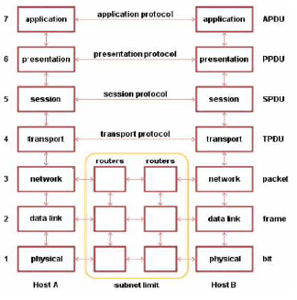
The OSI is a powerful model due to the specifications of its layers. Each layer groups a different set of similar protocols and functionality together. The requirement of a layer is that it only provides services to the layer above and only requests services from the layer below. This allows each layer to be isolated so that each can be changed without drastically affecting the other layers. As said before, the OSI is composed of seven layers, which are, from bottom to top: the physical layer, the data link layer, the network layer, the transport layer, the session layer, the presentation layer, and the application layer. Each layer provides different protocols and specifications for communication. To begin with, the physical layer describes the most basic hardware transmission of data. This layer encodes and decodes characters so they can be transmitted in a raw binary form. Here the protocols for this hardware transmission are specified, such as how to interpret amperage and voltage signatures for wired networks or amplitude or phase changes in particular frequencies for wireless communication. This is the most basic layer and only provides services to the layer above.
The next layer above the physical is the data link layer. Here data is transferred directly between network identities. This layer is also responsible for ensuring that the integrity of the data is held as it travels. To do this, the data link layer performs a mathematical operation on the bits of the data and sends the results of this operation with the data. Then at the receiving end, the same operation is performed on the data and that result is compared with the result sent from the first point. This operation is commonly called a checksum. The data link layer is also responsible for handling issues when data is broadcast to the network which can cause data collision. One solution commonly used is the Carrier Sense Media Access with Collision Avoidance or CSMA/CA which forces a station to wait for the channel to clear, the must first broadcast a signal telling other stations not to transmit until it is done. On top of the data link layer is the network layer. This layer is responsible routing data from end to end, where the data link layer is only responsible for transmitting data from point to point. As data is routed, it must also handle the issue that other systems may have different data link and physical layers. The most typical example of this layer is internet protocol which is widely used.
The fourth layer, the transport layer, breaks up the data so that it can be sent by the network layer. It knows where each data transmission is it is going, and how to send it so the data will be received correctly. The transport layer also reconstructs the data once it is received on the other end of the transmission. Finally the transport layer is also responsible for maintaining multiple connections. This layer is typically seen as the transmission control protocol or TCP. On top of the transport layer is the session layer. Here sessions for communication are opened, closed and managed. If a connection is broken or unused, the session layer will reconnect or refresh so that the connection is readily available to the layers above. The session layer also helps to handle communication of two or more users communicating at the same time, which is typically enforced by using token passing. A very common example of the session layer is a named pipe.
The final two layers are the presentation and application layers. The presentation layer focuses on translating data from the various types it can receive to what can be processes locally and converting local data to what others can process. One form of translating that is essential is encryption, which is handled here by the presentation layer. Also the presentation layer requests the creation and termination session from the session layer below. The final layer is the application layer. Here applications can talk directly with one another and files can be transferred. This layer is closes to what the user sees and a typical protocol of this layer is hypertext transfer protocol or HTTP. With these seven layers almost any network communication can be described.
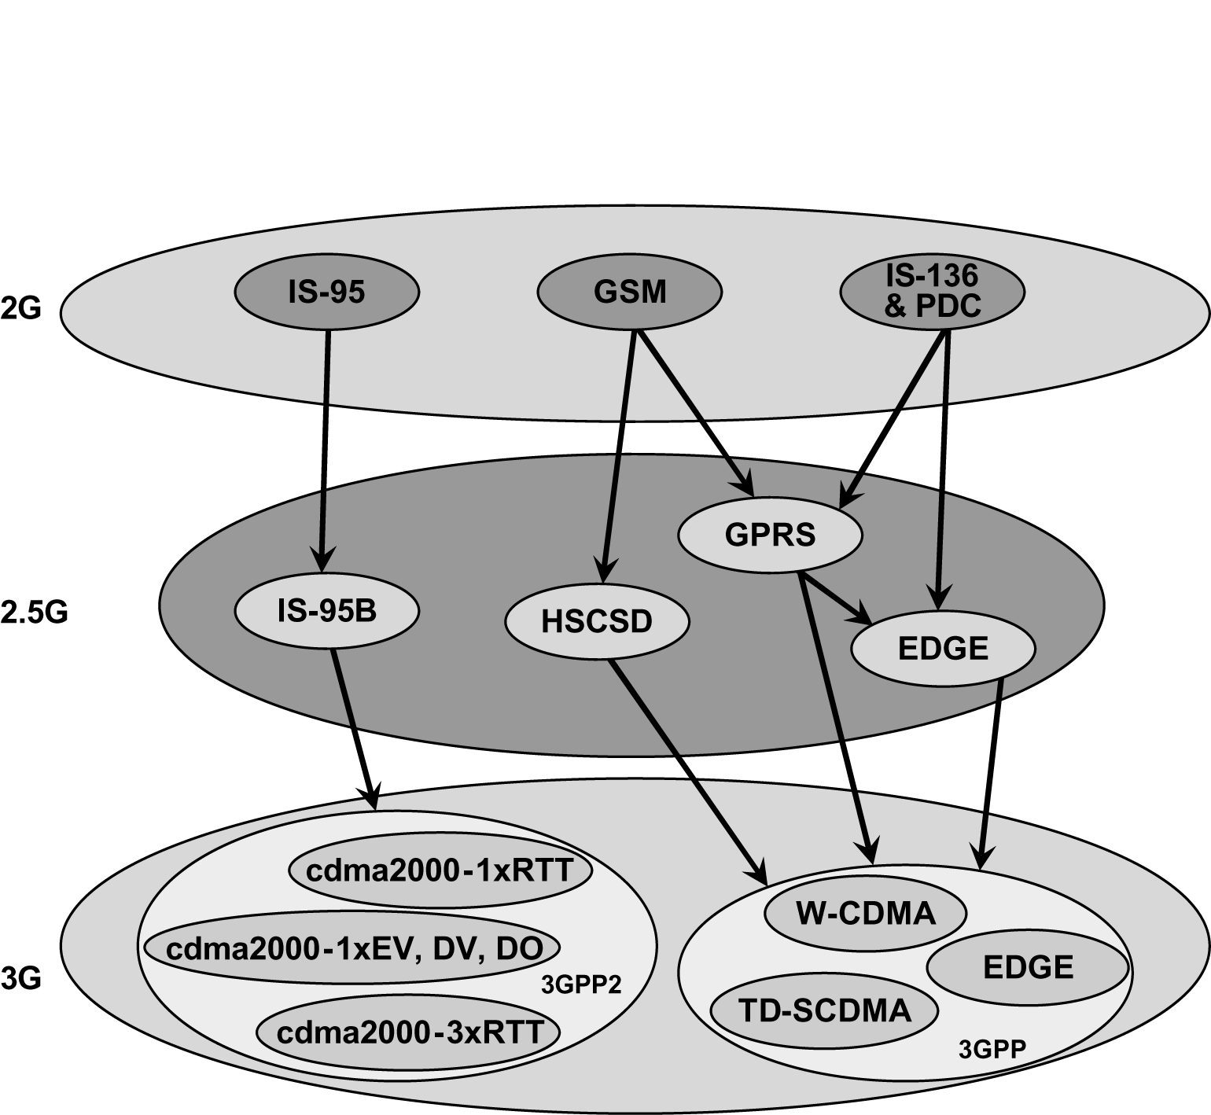
To fully understand how 3G falls into the layers of the ISO OSI, the roots of 3G networks, 2G and 2.5G networks should be explored. 2G is the second generation for cellular telecommunications and 2.5G is an evolutionary step which improved the performance of the 2G networks. The big change from 1G to 2G is that the signals sent and received went from analog to digital. Typical 2G networks are the IA-95, GSM, or IS-136. In these code division multiple access or CDMA, which is a particular communication method, was created. When moving towards a new generation, 2.5G was created. Here a packet switching domain was created which is similar to that implemented in the 3G. Some examples of this generation are the EDGE, IS-95B or HSCSD.
Then 3G networks are another set up in performance as they form the next standard for cellular telecommunications. The most common 3G networks are CDMA2000 or W-CDMA which is a wide band version of CDMA. Here all data is transferred by packet switching and must have a minimum data rate of 144 kilobits per second.
Being a networking method, 3G networks can be broken apart and seen through the layers of the ISO OSI. Most predominately seen in 3G networks are the bottom three layers: physical, data link and network. The protocols of the upper four layers are merged together in 3G networks, therefore they are not isolated and if one changes it will have a great affect on the others. For 3G networks, specific frequencies and data rates are specified so that the data can be transferred. Also, instead of using signal amplitude, 3G networks use phase changes in the signal to transfer data, so that power use is minimized. These specifications are the 3G physical protocols. The data link layer is seen in the media access control and packet data convergence protocols that are implemented in 3G networks, which provide the addressing needed for the network communication. Finally the network layer is defined by the radio resource control protocols.
By examining all of the layers of the ISO OSI, it can be seen how many different networking schemes fall into the different layers. This allows for an in depth analysis of these networks. As it was seen, the new 3G networks that connect new phones to the world, they can also be analyzed by the ISO OSI. However, in 3G networks, only the three bottom layers can be distinctly seen while the other top four are merged into one. This shows that the ISO OSI is a powerful and widely used model for networking.

Bibliography
- Rappaport, T. S.; Wireless Communications: Principles and Practices, Second Edition. Upper Saddle River, NJ: Prentice Hall, 2002.
- Peckol, James K.; Embedded Systems: A Contemporary Design Tool, Wiley, 2008
- Egan, Mike; ISO OSI 7 Layer Model forced with TCP/IP, http://mike.passwall.com/networking/netmodels/isoosi7layermodel.html, 2002

