
University of Missouri Columbia, Computer & Electrical Engineering
ECE 4220 – Real Time Embedded Computing Fall 2009
Final Paper: Nanite and Microbot Embedded Systems as Curing Ailments

Nanite and Microbot Embedded Systems as Curing Ailments
Justin Nicholson, Guilherme DeSouza
*University of Missouri Columbia, Department of Computer and Electrical Engineering

K E Y W O R D S _________________
Nanites, Microbots, Embedded Systems, Quantum Computers, Inhibitors,

_________________
A B S T R A C T ______________________________________________________
Novel ideas regarding the curing of nearly all of the most common causes of death are being considered through the use of intelligent nanites and microbots with embedded systems. Technology currently being the limiting factor, the computational side such as scheduling algorithms can already be investigated to a large degree. Comparisons between current and future curing techniques are discussed herein to progress the realistic and amazing future of medicine.
______________________________________________________

1. Introduction
Development of nanites and microbots with embedded systems involves the production of and assembly of nano-scale mechanical parts as well as embedded sensors and circuitry. While current methods for treating some of the most common causes of death include medicine and much easier production methods for production, the results for these are insufficient. New more sophisticated methods and new processes for future cures, although more expensive and not as easy right now might be a better approach. There is currently research being done to reduce costs and present a much greater chance for curing these common causes of death.
It is the goal of this paper to present current methods for the detecting and curing a few of the most common causes of death such as AIDS, cancer, and causes of strokes and heart disease as well to address some of the hurdles associated with future curing methods. Many of the current methods provide a glimpse of what’s to come and understanding these methods will also be incorporated in the devices of the future. One of the most important factors for future curing disease with the use of nanites and microbots is the use of embedded systems already understood and in use for various other applications such as object avoidance and scheduling algorithms are essential to these devices.
2. Current Methods
AIDS is currently addressed with medicines such as reverse transcriptase inhibitors, protease inhibitors, and fusion inhibitors.
Transcriptase inhibitors interfere with the HIV life cycle stopping the reproduction of the virus show below.
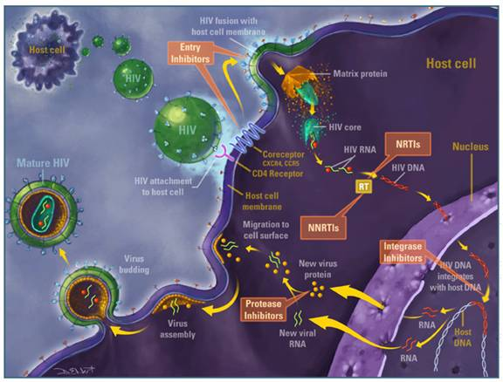
Figure 1: Transcriptase inhibitors
Protease inhibitors interfere with a protein used by HIV to create infectious viral particles show below.
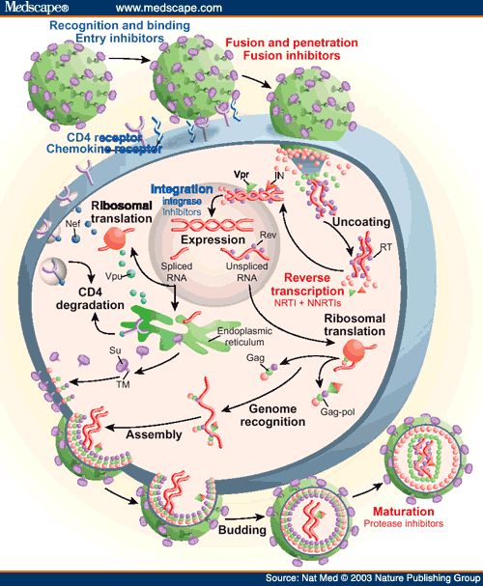
Figure 2: Protease inhibitors
Fusion inhibitors block the virus from entering the body shown below. 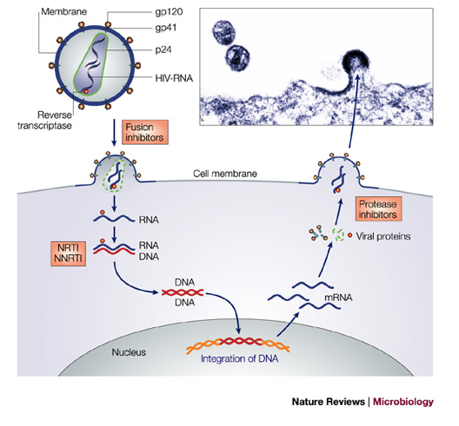
Figure 3: Fusion inhibitors
Cancer curing methods vary depending on the type of cancer and the stage that particular cancer is in. There are thousands of medicines and several other methods for curing cancer such as chemotherapy. These medicines attack the cancer and prevent its spreading effects. Chemotherapy kills cancers that are going through mitosis and reproducing. This has obvious drawbacks as our cells need to reproduce naturally. Cancer cells do reproduce more often and for longer periods before the original cell dies so this is a somewhat effective method.
Strokes, heart attacks, heart disease, and other cardiovascular problems are caused by plaque buildup, cholesterol buildup, and blood-clots. These buildups frequently stop the passage of blood flow in different parts of the body resulting in many problems. Current methods for treating these problems are clot-busters, and other medicines to remove the blocked areas. These however often lead to the clots, plaques, and cholesterol buildups moving further down-stream and increase risk of bleeding out. An image a blood clot is shown below.
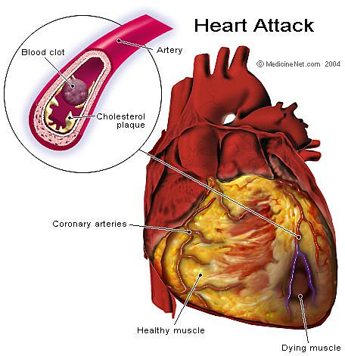
Figure 4: Blood-clot
Future Methods Proposed
Nanites and microbots have the potential of curing all of these more reliably and with less consequence. With the use of embedded systems these robots can have specific functionality to address each of these issues with little or no side effects. While current methods do not always target just unhealthy cells or paths of the body, future intelligent robots could traverse throughout our bodies looking for or luring viruses, clots, and cancerous cells. A method for curing AIDs for example could be a robot that has some of the chemicals and proteins that AIDs is normally attracted to and produced from healthy white blood cells. Once the virus is attracted to the robot, it would be a simple process of attacking the virus by either electrocution or mechanical impairment of important parts of the virus. Similarly cancerous cells could be damaged such that they are not able to reproduce again or even completely killed. These robots could also clear and detach clots, plaques, and cholesterols. This prevents future bleeding and clots downstream.
While the development of quantum computers, nano-assembly, and nano-machinery will be essential to these developments, embedded systems will be equally important for the traversal throughout the body, detection of, luring of, and curing of these common causes of death. Scheduling and object avoidance algorithms will be essential since things happen rapidly in the body and the amount of computational power will be limited due to the robots’ sizes. In addition to detect and deal with the viruses the robots will have to respond quickly and accurately. Priority will most likely be to not damage the body further, while secondly it must cure.
These scheduling algorithms and priority cannot be fully tested today; however, a lot of research can be done with current methods. Robots for example are being worked on to make object avoidance in three dimensions today. Robots that traverse through pipes to clear out important water passageways have very similar function to that of a blood clot removing robot. It will have to detect stopped or decreased flow, and then find the best way to start removing the clot, plaque, or cholesterol. In addition, techniques using electricity are being researched for the detection of cancers and AIDs patch-clamping methods show below.
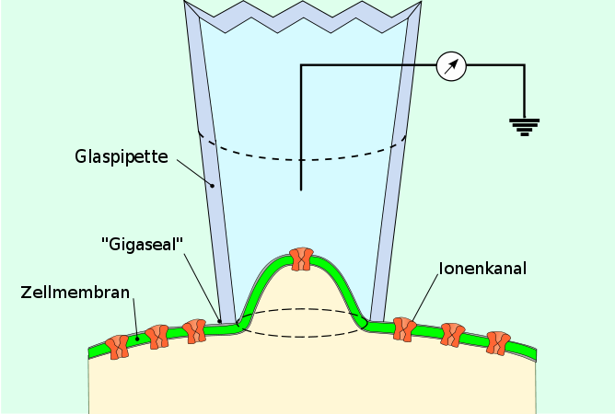
Figure 5: Patch clamp method

Conclusion
To quote Dr. Carl Sagan, “Somewhere, something incredible is waiting to be known” , however, when it is known but can’t be developed, we are truly gifted because we have the ability to investigate and bring it from the future to reality. There are many other benefits to nanites and microbots which have been and have yet to be revealed, however, there is definitely a purpose to it and it is already apparent that embedded systems will be an important part of the future.

The World Report 2002
National Institute of Allergy and Infectious Diseases
Theworlddrugs.net
Medscape.com
Nature.com
Yourtotalhealth.ivillage.com
MedicineNet.com
Wikimedia.org
Dr. Carl Sagan

