Portable GPS Prototype
The purpose of this project is to build a GPS prototype which collects latitude and longitude based on user input. The product can be used by people who want to record the distance of their last walking trip, or the routes their children have been taking. This will be made with a Garmin antenna and an arduino. A light on the unit will light when it is within satellite range and when a user presses a button the trip begins and the longitude and latitude information is received and recorded. When the user presses the button a second time, the trip ends. A user my hook up the arduino to the computer and view their travel on Google earth.
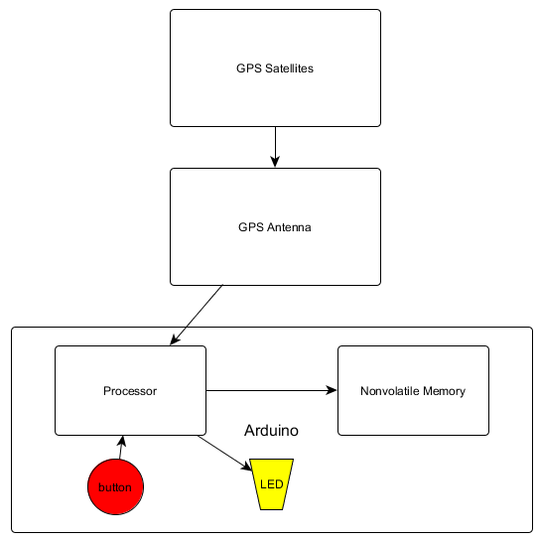
The following block diagram outlines how the implementation of this project will occur. As it can be seen, signals from the GPS satellites are sent down and received by the GPS antenna. At this point the Arduino will communicate with the antenna and begin to parse the data it is receiving. Once a fixed location can be determined, the Arduino will turn on the LED indicating to the user that a trip can be logged. Next the real time task will wait for the user to press the button which will indicate to start storing the data it is receiving from the GPS antenna to the nonvolitile memory. Then once the button is pressed again, the program will stop recording the trip. This trip can then be offloaded onto a computer for further viewing.
In this course we’ve talked about embedded systems and real time tasks. Both of these are needed in the implementation of this project. An arduino is an excellent example of an embedded system, not only does it include a microcontroller, but it relates with real time processes. This is because GPS is updated and the data must be updated fast enough to not lose data; the GPS is updated every second, so to insure data is not lost, all essential activities such as receiving and storing must be done within a second.
.

