ECE 4220: Project Proposal

SAE Formula Car Dash Module
Mark Schaumburg
2/24/2010

Project Description
For this project I plan to develop software for an in-dash embedded system to provide the user information from, and control of, several other modules within the car’s electrical system. The software will be developed on already created hardware (described later) that interfaces with other modules over a Controller Area Network (CAN).
This project will be implemented using many topics discussed in class, including multi-threaded programming, inter-thread communication, real-time scheduling of critical tasks, and data/resource protection using mutexes and semaphores. Using a real time operating system will allow for different tasks performed by the controller to execute with specific time constraints and priority levels, ensuring that time critical processes run properly.

System Requirements
This project must satisfy several requirement needed for use in the formula car. These requirements cover several areas including user interface, data acquisition, and inter-module communication.
The module requires a user interface that displays information and handles input from the driver. Input needs to be taken from the driver to change settings, navigate menus, etc. This input should be sampled at least once every 100ms and be able to handle button bouncing, simultaneous presses of buttons, holding buttons down and other common input handling problems. Additionally, the module needs to display information to the driver, and needs to update at least once every 200 ms to ensure any changes are smooth.
The module also requires time-sensitive data acquisition handling. Specifically, it needs to monitor the period of a square wave from a rotary encoder in the engine to calculate engine RPM. The software needs to make sure that the signal is sampled often enough to give an accurate RPM reading. This can be done by using a hardware interrupt that pre-empts the other processes in the system.
Most importantly, the module needs to be able to communicate with other modules inside the car. This is accomplished by connecting the modules via a CAN network. The module needs to efficiently respond to requests from the network, as well as request data in a timely and organized matter.

Hardware Description
The module software will be developed on existing hardware designed by another member of the formula car team. The module is developed around an Atmel Mega644 8-bit RISC microcontroller with a system clock of 9.216 MHz. The user interface consists of 9 buttons, a 4x20 character LCD, and 6 LEDS (2 Red, 2 Green, 2 Blue). Connectors are provided to connect to the CAN network and to connect the RPM sensor.

Software Description
The software will be developed and written in C using AVR Lib-c and the AVR-GCC compiler. The module will be developed as a multi-process and multi-threaded system. The system will be developed on a real-time operating system designed to run on AVR 8-Bit microcontrollers (either FreeRTOS or FunkOS). The software will be designed to contain 5-6 concurrently running processes. This consists of User Input, User Output, Data Processing, CAN Requests, and CAN Responses. A use-case diagram is shown below. (The processes will communicate via FIFO-mailbox style functionality provided by the operating system)
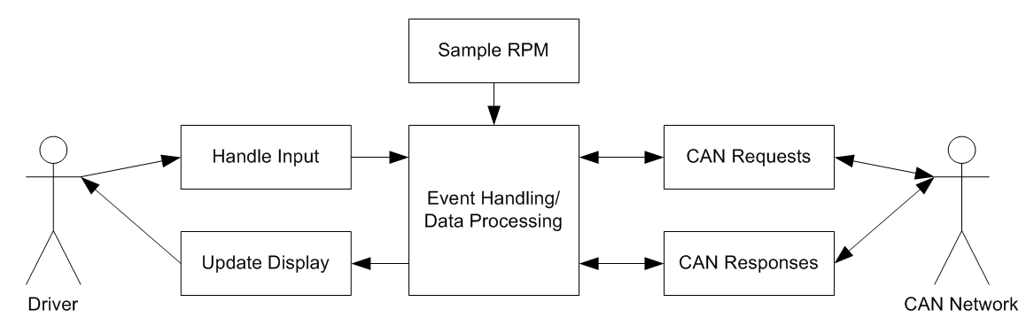
Figure 1 - Use-Case Diagram

Class Relevance
The project will implement many design elements discussed in class. The most extensively used concept is the idea of multi-process and multi-threaded program execution. As discussed earlier, the software is designed around several concurrently running processes. Additionally, each process will contain multiple threads to allow parallel execution within the process itself. This style of software design is useful because the system needs to be simultaneously doing many different things. Additionally, many of the system elements need to wait on the state of various system parameters. A multi-threaded design allows other tasks to be carried out while some tasks are waiting on data or resources. To communicate between processes and threads, FIFO style mailboxes will be setup using functionality provided by the operating system.
The system will also use common data and resource protection techniques discussed in class. This includes the use of semaphores and mutexes. The CAN Communication processes contain threads that will use mutexs for resource protection. To prevent the two separate communication processes, from interfering with one another while trying to communicate with the CAN Controller ic, a mutex will be implemented that will block other processes from using the interface until communication is complete. Additionally, semaphores will be implemented throughout the system to protect certain sets of data while they are being manipulated by a specific process.
Finally, the system will make use of real time scheduling functionality provided by the operating system in several places in the design. One example of this is to guarantee that button presses are handled at specific frequency and the LCD is updated regularly. These processes will be scheduled to run at specific periods using real time functionality provided by the operating system.

