Spring 2010
ECE 4220 – Real Time Embedded Computing | Mark Schaumburg

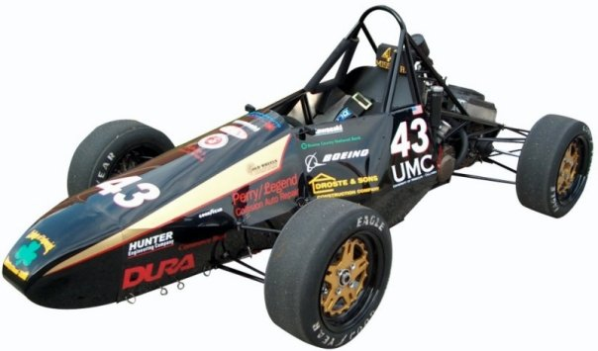
SAE Formula Car | Dash Module using FreeRTOS

Project Description
The purpose of this project is to implement software for a Dash module for Mizzou Racing’s SAE Formula Car. This module is used to monitor the RPM signal from the engine, make the data available over the CAN network, and also supplies a graphical user interface to allow the user to scroll through many pages of diagnostics information.
To satisfy the requirements for ECE 4220, the system is implemented with an open-source real-time kernel called FreeRTOS. Real-Time tasks scheduled are used to monitor the RPM and handle communication on the CAN network, while several lower priority tasks handle non-critical system function such as controlling an LCD or LEDS and handling button input and the user interface. Inter-process communication (IPC) is provided by the operating system through FIFOs (called queues). This is the primary communication interface between processes. The operating system API also provides semaphores for process synchronization and mutexes for mutually exclusive access to shared variables and other system resources.

Hardware
The module hardware centers around an Atmel AVR Mega644p 8-bit processor clocked at 9.216 Mhz. This provides control and monitoring of a 4x20 Character LCD, 6 Indicator LEDS, 9 buttons, in addition to a CAN communication IC (MAX2515) that is interfaced through the SPI bus on the microcontroller. Internally, the AVR has 64k of flash ROM and 4k of SRAM.
Figure 1 - Hardware Block Diagram

Software

Development
The software for the dash module was written in C using the avr standard library, avr-libc. The source was compiled using the open-source WinAvr GCC compiler and developed in the free, but closed source, IDE provided by Atmel called AVR Studio.
The source compiled to about 13k of flash and used about 3k of statically defined RAM. The OS tick was set at 100us.

FreeRTOS
FreeRTOS is a free and open-source real-time scheduling kernel. The API is in C, and most of the source code is written in C, making the system very portable between different architectures. Assembly and architecture-specific C code is only used in a few places to implement the context switch and enable or disable interrupts. This code is contained in a file for each architecture it is ported to. For this project, a port existed for the AVR architecture. The only thing that had to be changed was the names of the timer registers used to implement the RTOS tick timing.
The kernel itself is highly-customizable and easy to use. Scheduling is round-robin and optionally allows pre-emption and task priorities. API functions are included that allow tasks to be scheduled in hard real-time, soft real-time or non real-time. Additionally, timing constraints can be set to be periodic or response based.
The kernel also contains a full function inter-process communication API. Communication between tasks is done using objects called Queues, that function as FIFOs with a message size and buffer size that is fixed upon creation. In addition to typical FIFO features, the API also provides the ability to write to the front of the Queue instead and also allows a task to “peek” at the next message, effectively allowing the task to receive a Queue message without taking the message of the queue.
In addition to Queues, FreeRTOS also provides task synchronization functionality, including binary semaphores for task synchronization, counting semaphores for resource management, and mutexes that allow for mutually exclusive access to shared variables and system resources. To help prevent priority inversion and deadlocks, the kernel does not allow a task to hold more than one mutex at time.
The OS tick is set to 100us.

Tasks

Priority 1 Tasks

Button Inputs – vTaskButtons()
This task handles button inputs to the system. Pushing and releasing buttons usually does not create a perfect transition from low-to-high and high-to-low. The metal contacts will often bounce against each other, creating an unstable input for several milliseconds. Additionally, button handling requires that a button be released before it is registered as pushed again. This prevents the system from continuously registering a button is pushed while it is held down. In an embedded system without multi-tasking, processing time is wasted waiting for these two events to be handled because both require looping delays. In the context of a pre-emptive operating system, the buttons can be handled more efficiently by yielding to another task while the delay is executed. Additionally, this task generates button events each time a button is pushed. These events are sent into a queue that can be accessed by other tasks in the system. The advantage of this system is that only one button event is created per button push. This reduces the complexity involved when multiple tasks want to have access to button information.

LCD Control – vTaskLcd()
This task controls the character LCD using a 4-bit data interface with a 3-bit control interface. The library used for LCD control was modified from source code found on the internet. This task reads from a queue that contains messages that specify an LCD Command, such as write, clear, cursor control, an x and y value that determines where the action will start and a null terminated string that contains the characters to be written to the LCD.

LED Control – vTaskLeds()
This task controls 6 LEDs attached to the Atmel microcontroller. Each iteration of the task loop checks a queue containing control messages with the led to change and the period that it blinks at. It then checks the system clock to determine whether or not each LCD needs to turn on. If the change in the clock is between 0 and half the period of LED, the light is off, between the half and whole period the light is on. When it exceeds the period the counter for the LED is reset to zero. If the LEDS period is 0x00 or 0xFF, the LED is always off or always on, respectively.

Priority 2 Tasks – Non-Realtime

User Interface – vTaskUi()
This task controls the user interface for module. It is still not a critical task but because it uses several processing intensive<stdio.h> functions the task is made to be higher priority so that it is not starved off processing time, resulting in delayed response to inputs and screen updates. This task is basically a state-machine that moves between functions for each page that creates the characters to display for each line of the page and sends it through the LCD event queue. Each page function also monitors the Button Event Queue and a global data update Semaphore. Unless a relevant button is pushed or new data is available, the screen is not redrawn. This prevents clock cycles from being wasted to redraw the exact same data on the screen. When another task updates the Global Data store, it posts to a binary Data Update Semaphore. This triggers the UI task to respond. The UI task then waits on a Global Data Mutex to ensure the data doesn’t change while the page function copies the Global data into its local data storage. If a Button Event is found in the Queue and the page defines a next page for the specified button, the current page function exits and the new page function is entered. Upon entering a page, the page function updates its data and redraws the screen, regardless of whether the Global Update Semaphore has been posted.

Priority 3 Tasks – Soft Realtime

Data Handling – vTaskRpm()
This task handles updating the RPM data and also requesting data from the network. To calculate RPM, an interrupt handler triggers on the rising-edge of the RPM signal. This handler simply writes to a Queue using a special API function that calculates the time between the current RPM pulse and the last pulse, to a queue from an ISR. It also posts a Semaphore that signals to the Data handling task that a new RPM value is available. The data handling task waits for this semaphore, and then calculates a new RPM based on an average of the last 10 RPM values. This creates smoother RPM data, and is less susceptive to noise on the RPM line. After the RPM value is calculated, the data handling task signals the Data Update semaphore to indicate that a new value has been calculated. While delayed execution of this task will not cause a system failure or introduce critical errors. The RPM data needs to be as up to date as possible. A real-time response of 10-ms is desired.

Priority 4 Tasks – Hard-Realtime

Can Communtication – vTaskCom()
This task is the most important in the system. The CAN controller has an internal message buffer, but it is only 8 messages long. To ensure that all messages are received, the CAN communication task needs to pull the messages off the CAN controller as soon as possible. To facilitate this, an interrupt handler is linked to an interrupt pin on the CAN controller that indicates when a new message is available. The interrupt handler simply signals a binary semaphore that causes the CAN communication task to unblock and because this task is highest priority, it will unblock on the next OS tick regardless of the state of the rest of the system. The task then builds the required response message and sends it, or if the message was a return message with data, it stores the data. To ensure quick and efficient communication and to ensure that no messages are lost, the response time of the task must be less than 10 ms.
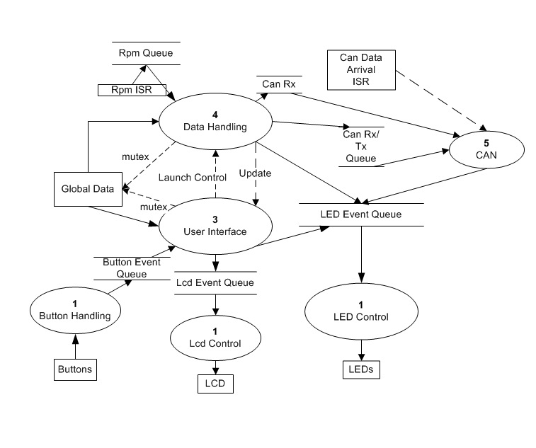
Figure 2 - Data and Control Flow Diagram

Testing

Setup
To test the system, additional software was written for a wireless serial to CAN module that used another Atmel AVR Mega644p. This module simply sent a message over the network to the Dash, which returned the RPM and two timestamps representing the time the message was received and the time the return message was sent. This data was then printed to the terminal.
To simulate the engine pulses, a function generator was used to create square waves of specified frequency that were sent to through the RPM detection hardware. The RPM interrupt handler runs on every rising edge of the clock, so system load could be increased or decreased by increasing or decreasing the frequency of the input signal.

Results
The graphs below show the RPM overtime and also the response times of each message. The RPM is increased from around 100 to 9000 RPM. As the RPM is increased, the system shows some spikes in response time but all of the spikes are easily within the 10ms threshold.
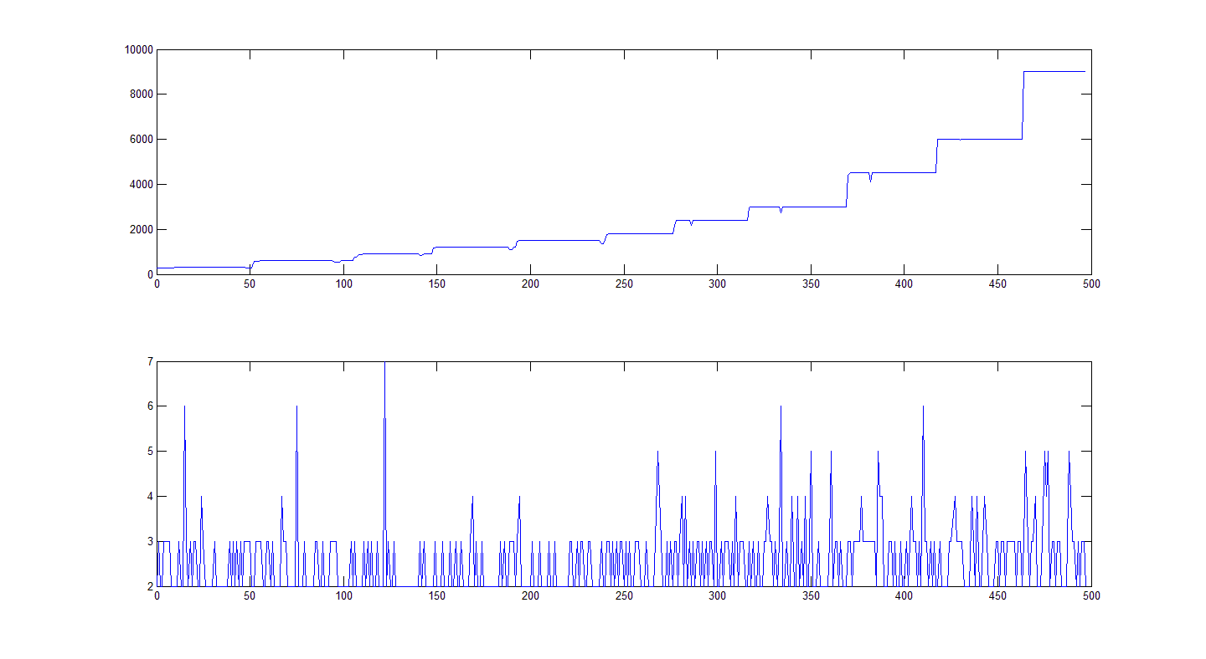
Figure 3 - Testing Results

Observations and Conclusions
Several observations can be made about implementing the Dash module with FreeRTOS. The first observation is that while FreeRTOS allows for increased performance, it requires a lot of memory for all the task stacks, queues, and OS requirements. If performance were of the utmost importance, rather than ease of design, the design would probably be best implemented without a kernel. Another observation made was that even though a time stamp was taken immediately after the RPM was calculated, the OS tick limited the resolution of the calculation to +/- 1 ms. This caused the RPM to often be several hundred revolutions off. To fix this, I changed the OS tick to 100 us. This fixed the problem, but the user interface lagged slightly as a result of additional OS overhead.
Overall, the project was a success. All the real-time constraints were met and most of the system above worked as defined. However, the implementation was not without problems. In addition to the problem with RPM mentioned above, the biggest problem I faced was getting the modules to work without the programmer attached. The AVR microcontrollers can be programmed in-circuit without a software boot loader using the SPI interface. However, the CAN controller also uses the SPI interface to operate. While I was not able to completely solve the problem, I do have some theories on why it was occurring. If the module is reset by the ISP while the CAN controller communication is taking place, the CAN controller may think that the SPI commands coming from the programmer are intended for it. This might cause possible bus contention problems that could be affecting the operation of the module.

Source Code

Key:
MS-Written by Mark Schaumburg
OTHER – Open-Source code written by others (the code contains licensing and author information)
OTHER/MS – Open – Source code modified by Mark Schaumburg
FreeRTOS Source and API Documentation is available at FreeRTOS.org

System Initialization and Parameters
dash.c - MS
dash.h - MS

Task Code
Dash_buttons.c - MS
Dash_com.c - MS
Dash_Data.c - MS
Dash_lcd_leds.c - MS
Dash_Ui.c

Additional Libraries and support files
Lcd.c – OTHER/MS
Lcd.h – OTHER/MS
Mcp2515.c - OTHER
Mcp1515.h – OTHER
IMCPDefs2.h – OTHER/MS

