Russ Butler
ID 12309946
ECE 4220
Date: 5/2/12

Audio Driver Project Report

Abstract

The objective of this project was to create an audio driver for a TS-7250 board. This was accomplished by creating the necessary hardware, the kernel mode audio driver and finally a user mode program, which uses the audio driver to play sound. Using this approach, a high-quality, dual-channel audio player was created. This project was successful in its goal of creating an extension to the TS-7250 board to allow it to play audio.

Introduction

The project proposed here is an audio driver for the TS-7250 board, along with the appropriate hardware extensions to allow the playing of audio. This project is broken down into three major parts. The first part is the hardware and software, which are responsible for the conversion of the digital audio data into sound, along with controlling the timing of the audio. The second part is the kernel mode driver, which controls the audio hardware, along with providing a software interface to allow user mode programs to play sound. The third part is the user mode program, which uses the interface provided by the kernel mode driver to play audio stored in wave files.

Relevance

This project is relevant to the class because it uses many concepts used in class. For the audio to be played correctly, the software must use real-time scheduling. This project also uses the real-time FIFOs discussed in class to send data from the user mode program to the kernel mode driver.

Implementation

The audio player was implemented in three different components, the hardware and embedded software, a kernel mode driver and a user mode program. Audio data was taken from a wave file in the user mode program and written to the kernel driver. The kernel mode driver then sent this data to the hardware when it received a data request signal. A block diagram of these components is show below: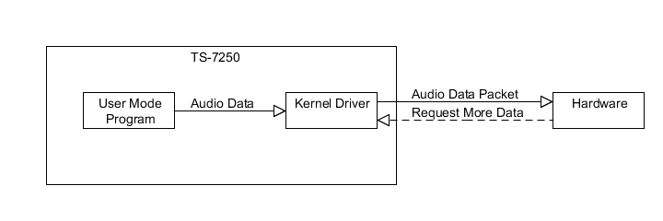
Figure 1: Block Diagram of System

Hardware and Embedded Software

The hardware consists of several parts. The microcontroller used for the hardware is the Atmega168. This microcontroller is responsible for requesting audio data from the TS-7250 board by driving pin 0 of port B low, reading the audio data via the SPI port and finally outputting the data using pulse width modulation.
The pulse width modulated signal from the microcontroller is passed through a voltage divider to lower its voltage. The signal is then fed through an op-amp to boost the signal strength. Finally, the signal goes through a high-pass filter to strip out all the DC components of the signal before it is sent to the speaker. This is done for both the left and right audio channels. A schematic of this circuit is shown below:
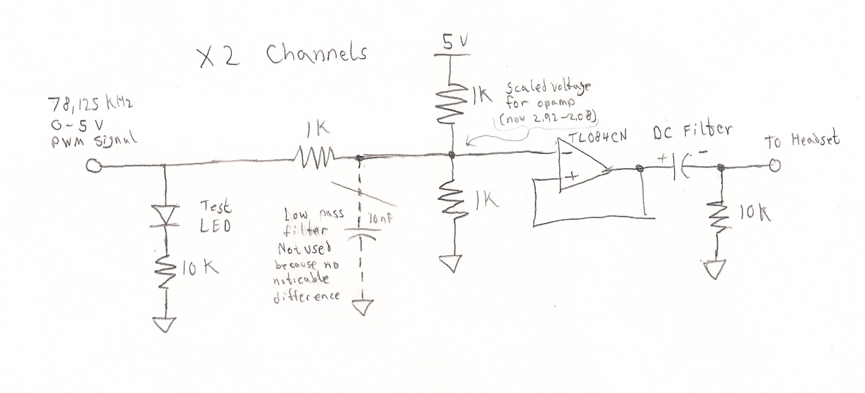
Figure 2: Audio Signal Path
Circuitry was also made for requesting more audio data from the TS-7250 board. Because the Atmel microcontroller runs on 5v and the TS-7250 board runs on 3.3v, voltage level conversion circuitry had to be made. This was implemented with a transistor, where the collector was pulled to 3.3 with a 1k pull-up resistor. A diagram of this circuit is shown below.
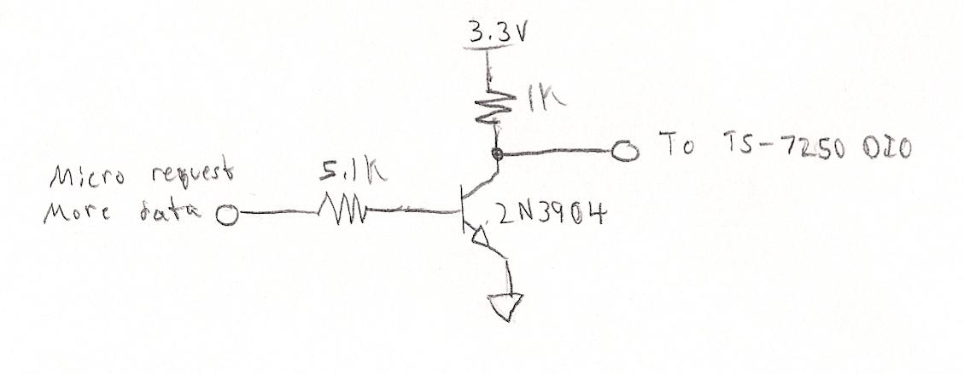
Figure 3: Request More Data Circuitry
Several other circuits are required for this board to operate properly. To supply power to the board, a 5v linear regulator is used. To program the microcontroller, a 2x4 pin connect is used to allow for In System Programming (ISP). For error detection, a red LED was added to indicate if any problems were detected. To allow the microcontroller to run accurately at the correct frequency, a 20MHz crystal oscillator is used, along with 12 pF capacitors on each of its legs. Finally, decoupling caps were used to reduce noise and allow for a cleaner audio signal. A picture of this circuit is shown below:
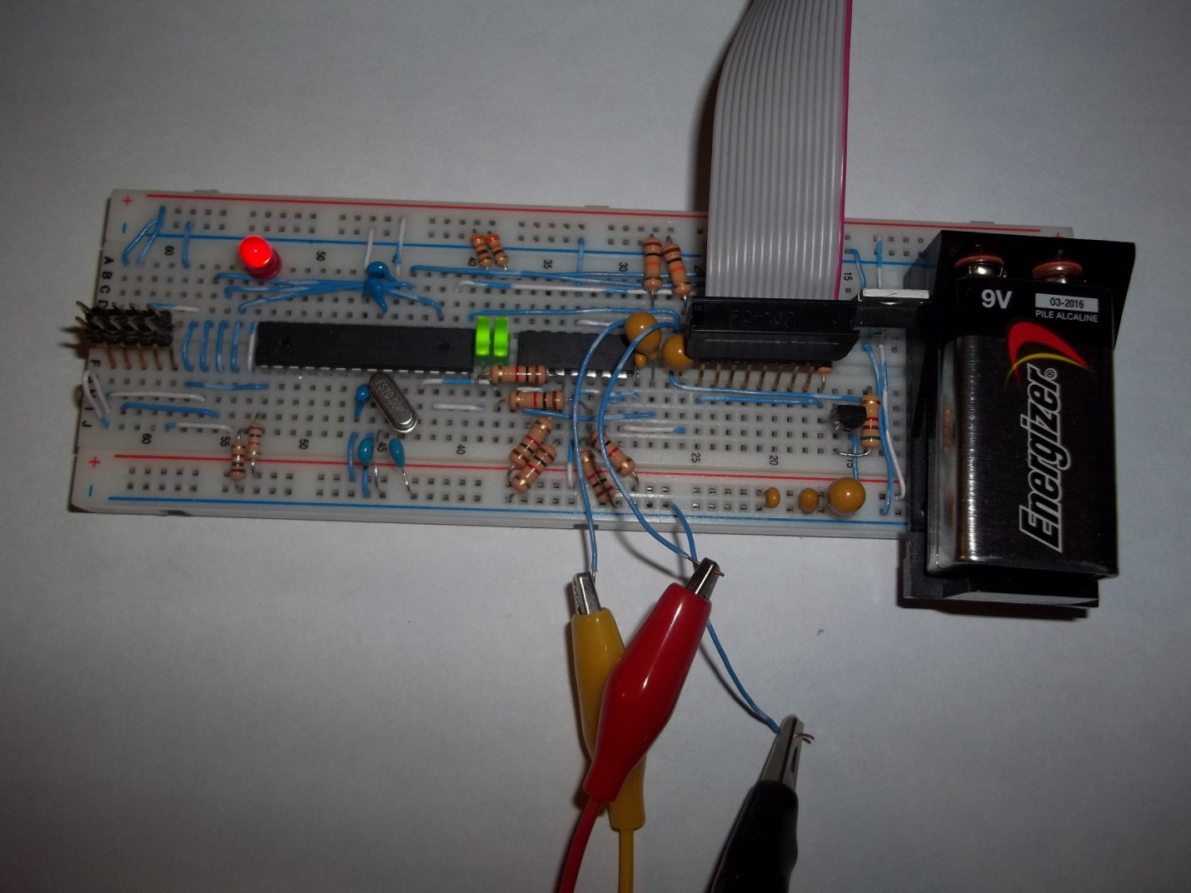
Figure 4: Picture of Hardware

To achieve correct functionality, the assembled board had to be programmed. The initialization part of the board’s software set up two PWM channels for left and right channel audio, a 16-bit timer to provide the 44.1 KHz ticks for audio output and the SPI module to allow reception of audio data.
Because of the high data rate coming from the TS-7250 SPI port, 4MHz, the code had to execute as fast as possible. With the processor running at 20 MHz and SPI data reaching the processor every 0.5us (8 bits / 4MHz), the processor had 40 clock cycles to store the data. Initially, SPI events were handled in an interrupt handler. Due to this extreme speed constraint, interrupts proved to be too slow. Using the simulator in AVR Studio to step through the assembly of the SPI interrupt, it was found that it took approximately 70 clock cycles to handle the interrupt, even with full optimization. The code was then restructured to use a loop and polling, rather than interrupts. This provided a massive speed increase and allowed for the SPI data storage routine to be completed in approximately 17 clock cycles. This same structure allowed the audio tick and error detection events to be handled sufficiently fast. Below is the flow chart describing the function of the program:
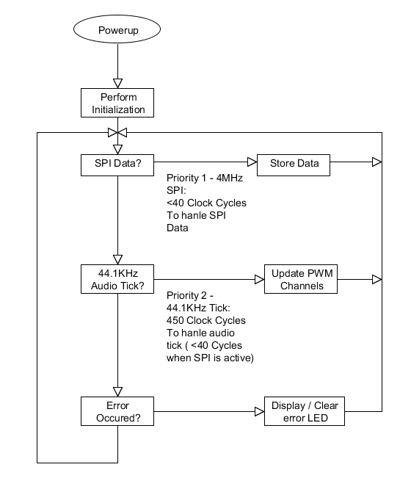
Figure 5: Embedded Software Flowchart

Software

Kernel Mode Driver

The kernel mode driver provides an interface to user mode programs and allows them to play audio, along with handling interrupt requests sent by hardware. A request for more audio data is indicated by pin 0 of port B being driven low, which triggers an interrupt. This causes the kernel mode driver to read a block of 400 bytes from the real-time FIFO 0 and then write them via the SPI port to the hardware.
Aside from basic functionality, error detection and debugging features were added, so correct functionality could be verified and lockups could be avoided. If DEBUG_MODE was defined, then the debugging features would be enabled. On start, the SPI module would be speed-tested, and would record the time it took to transmit 1000 bytes of test data. Also, a real-time task would be created for collecting performance data. This task would print to the kernel console the number of incomplete audio packets per second, which indicate that the user mode program is unable to generate audio data fast enough. Also implemented was hardware malfunction detection. If the request data pin got stuck low, the software would detect that was causing repeated interrupts (active low interrupts) and automatically shut off the interrupt source. This was to prevent the TS-7250 board from crashing when a software error was encountered.

User Mode Program

The user mode program opens a wave file at the location specified by a user. It then parses through the wave file to find the relevant format information. If the wave file is of the correct type, it then proceeds to extract the audio data from it. The audio data is then written to real-time FIFO 0. This causes the kernel mode driver to read the data and send it to hardware to be played as sound.
Only wave files with the correct format are supported by this program. For the wave file to be playable, it must have two audio channels, have a sample rate of 44.1 KHz (standard CD bit rate) and 8 bits per sample (standard is 16). To convert arbitrary sound files to this format, the program Audacity was used.

Results

The kernel mode driver, in conjunction with the external hardware, was able to create high-quality audio at a high sampling rate on two audio channels. The audio sample rate achieved by this project was 44.1 KHz, which is the same sampling rate used on a standard CD. The numbers of bits per sample were only 8 as opposed to 16 on a standard CD. This lower bit rate slightly decreased audio quality, and added a minor static sound to the quiet part of songs but aside from this provided a high-quality sound.

Conclusion

Using a hardware extension and a kernel mode driver audio player, an interface was created for the TS-7250 board. This project required the application of concepts learned in class, such as real-time scheduling, kernel modules and interprocess communication. This project accomplished its goal of creating a high-quality audio player extension for the TS-7250 board by allowing near CD-quality audio to be played.

