Final Project Proposal
Course: Real time embedded computing
Instructor: Dr.DeSouza
Ning, Guanghan paw:gnxr9
0. Description
The project I have in mind is a simulative Vehicle Retrieval System where a camera would capture pictures and localize the license plate, segment the characters and recognize them. Since I am working in an image processing lab and researching in this area, I am hoping that I can implant my program to Ts-7250 or other hardware with necessary peripherals to simulate the process of vehicle retrieval. The program is in C++ and besides that, new code must be written as a shell to call the core implementation. Real time concepts are involved. After segmentation of the plate into several characters, multiple threads will be created to recognize each character. If one of those threads have met a problem, at least some of the characters will be recognized. This is very important in that if one character is missing, the program would still provide important information for the traffic police.

Another project I have in mind is a WiFi based Android cell-phone game that I implemented as an undergrad student( with a teammate). Now android allows developers to implement parts of the app using native-code languages such as C and C++ with a toolset called NDK, so I am wondering if I can change the game so that the board could be a server for client cell-phones to play the game. The game was originally ad-hoc mode but I wish the board to be the server that only receives and sends messages to clients. Hopefully, pthread, semaphore, shared buffer or producer- consumer model will be explored. It is just an interesting thought for the moment. I will try to see if I am able to do this.

1. Hardware part
A webcam might be needed, a new kind of board might be needed or not.
For the other possible project, two android cell-phones and the TS-7250 board as the server are needed.

2. Software part
Besides C code for kernel module. C++ code or java code with C code will probably be incorporated.

3. Overall flowchart
vote
thread set 1
derive ROI
Features of the Model
thread set 2
shared buffer
Segmentation
thread set 3

For the first possible project.

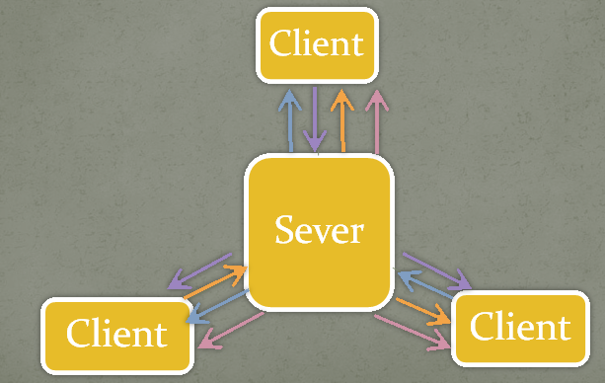
For the second possible project.

4. Real time concepts that I use
Threads:
Multiple sets of threads will be used to deal with different characters on the license plate.
One set of threads will compare different features with its character.
Shared buffer:
The segmentation step and the alignment step after it stores information in a shared buffer for different threads to know their ROI. The Region of interest is where they would analysis and get to know the character in it by extracting features and count votes from a trained model.
Semaphore:
The idea of character recognition is to first select 10 voters from 100 candidates from the model. The 10 candidates whose feature have the minimum distance with the character the thread is dealing with will be the voters. They vote for the character. If 6 out the 10 votes is from class 3, which means they represent number 3, having more votes than any other class, then the character will be recognized as 3.
When trying to gather voters from the model, one thread will have to modify the model when trying to find 10(out of 100) best voter candidates from the model by setting the already-found candidates' features huge ; while for another thread who is looking for the first best voter, it resets the model. There is a critical region here where threads can't reach at the same time. So a semaphore is needed to ensure that each thread have access to the right data.

Producer-consumer model with broadcast:
For the android game, if I decide to do it, then it will need two producer-consumer models. Two clients send their current state to the server, the server computes the next states and send it to both clients, updating both clients status. It is centralized.
Sending message
After one player generates his dice number and chooses his running plane, the phone sends userID, dice number, and running plane number to Sever, and sever will send the message to all clients.
Receiving message
No matter clients or server, there
always is a thread trying to receive
message. Once it receives not null
message, it will store them for
further use.

