Project Proposal
Project Information
Name of the Organization: ECE Real Time Computing
Project Title: Final Course Project-Monitoring system used for detecting speeding of vehicles
Project Time: March, 20 2013 - May, 20 2013
Prepared by: Hancheng Wu

Project Summary
1.) Project Background
In nowadays real time devices exist everywhere in engineering world, helping people improve their life. As the design of final project of ECE 7220 Real Time Computing course, not only do I want it to cover all the content I learn in the class, but also to be useful for real using. What I am going to do in this project is to implement the design of a monitoring system used for detect speeding of vehicles for safety consideration and to analyze and optimize the performance of the design using the knowledge I learn from the ECE 7220 course.
2.) Project Objectives
  - To design the monitoring system.
  - To prototype the design in the lab.
  - To analyze and optimize the design using knowledge I learn from the class.

Project Methodology
1.) The Project Approach Summary
This project consists of three main parts, part1 being speeding detection block, part2 being image capturing block, part3 being information transferring block.

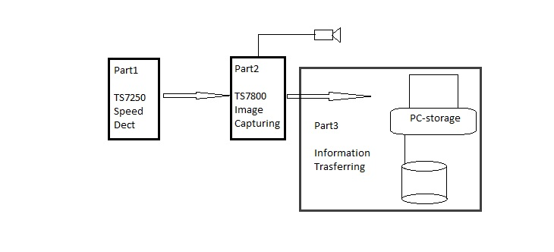

Fig1. System Blocks

2.) Speeding detection-part1
In this block, I am going to use TS7250 board along with two sensors to detect the speed of passing vehicles. Once there is a speeding happening, a triggering signal will be sent to part2 and part3.

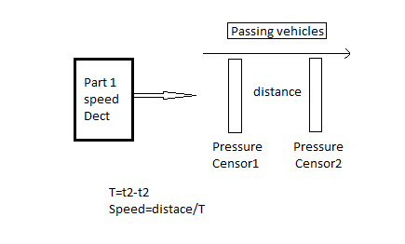

F
Fig 2. Speed detection

3.) Image capturing block-part2
In this part, a TS7800 board will be used with a camera to capture the image of the speeding car once they receive a signal form part1.

4.) Information transferring block-part3
To store the captured image, a PC (seen as a database) will be connected to TS7800 board. Whenever an image is captured, it will be sent to desired database immediately.

5.) Correlated course information
Part1: Real time kernels and operating systems, Real time scheduling algorithms;
Part2: Interrupts, Scheduling and Task communication, cooperation and synchronization;
Part3: RS232 standard communication.
Project: Analysis and optimization

Performance analysis and optimization
In this section, analysis of each part mentioned above should be accomplished following the suggestion of optimization.
1.) Part1
Concentrations should be given to the real time constraint. The design is supposed to response to a very high speed in a limited time so that following processing could be made in time.
2.) Part2
Concentrations should be given to how to acquire high quality images with high speed, what camera I should use, how to manage parallel tasks and the inter-process communication.
3.) Part3
In this part, other than just store the image and the information, I am considering applying an automatic vehicle license plate recognition program to the system.
Conclusion
Around the speeding detection, what matters is that how the knowledge learned in the class will be applied in this project and how I use them to analyze and optimize the project. Every single detail should be included in the final report.

