Project Proposal
Project Information
Name of the Organization: ECE Real Time Computing
Project Title: Final Course Project-Monitoring system used for detecting speeding of vehicles
Project Time: March, 20 2013 - May, 20 2013
Prepared by: Hancheng Wu

Project Summary
1.) Project Background
In nowadays real time devices exist everywhere in engineering world, helping people improve their life. As the design of final project of ECE 7220 Real Time Computing course, not only do I want it to cover all the content I learn in the class, but also to be useful for real using. This project is to implement the design of a monitoring system used to detect speeding of vehicles for safety consideration and to analyze and optimize the performance of the design using the knowledge from the ECE 7220 course.
2.) Project Objectives
  - To monitor vehicles and to detect potential speeding behavior.
  - To capture the picture of speeding vehicles.
  - To transmit captured data to database.

Project Methodology
1.) The Project Approach Summary
This system consists of three modules, module1 for speeding detection, module2 for image capturing, module3 for data transferring and storage

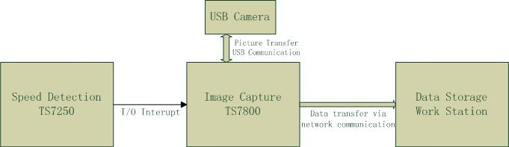.

Fig1. System Architecture

2.) Speeding detection
In this module, a TS7250 board along with two pressure sensors are used to detect the speed of passing vehicles. Once a vehicle passes over the pressure sensors, signals will be sent to board through physical pins. Then the real time application running on the board will calculate the speed of the passing vehicle. If speeding happens, a triggering signal will be sent to Image Capture module through I/O as an interrupt source. Actions of image capture then will be taken. Following formula is used to calculate the speed,
$S=D/(T_{P1}+T_{p2})$ ,
where D stands for the distance between pressure sensor1 and pressure sensor2 and $T_{P1} and T_{p2}$ stands for the times signals are detected by the application.

3.) Image capturing
To implement this module, a TS7800 board is used with an usb camera to capture the image of the car once they a speeding behavior is confirmed and sent by speed detection module. Furthermore, program will transfer the data to the data storage module via network communication.

4.) Data Storage
To store the captured image, a PC (used as a database) will be connected to TS7800 board through internet. Whenever an image is captured, it will be sent from image capture module to database immediately.

Performance analysis and optimization
In this section, analysis of each part mentioned above should be accomplished following the suggestion of optimization.
1.) Speeding detection
Concentrations should be given to the real time constraint. Vehicle would not stop running when the system is working. The design is supposed to response to the high speed of vehicle in a period of time so that following processing of image capture could be made in time. More specifically, after the time that detection module uses to send out the signal and image capture module uses to notify the camera, the position of the car can be predicted.
2.) Image capturing
When never a signal is detected, main thread will create a new thread for current speeding car. The new thread will in charge of activating the camera and receiving image data from camera. Main thread will keep waiting for signals. Another thread will send the data acquired to data storage module. One problem would be that usb camera may not be that fast, but this does not affect the system structure and the algorithm.
3.) Correlated course information
Real time kernels and operating systems, real time scheduling algorithms; interrupts, scheduling and task communication, cooperation and synchronization; USB and RS232 standard communication.

The procedure and timeline

April 7-13: Look over devices, general algorithms on how to proceed.
April 14-20: Implement speed detection module and formulate algorithms for image capture module.
April 21-27: Implement image capture module and formulate algorithms for storage module.
April 28-May 4: Implement storage module and test the whole system.
May 5-11: Reserved one week for analysis and optimization.
May 12-18: Finish presentation.
Conclusion
Around the speeding detection, what matters is that how the knowledge learned in the class will be applied in this project and how to analyze and optimize the project.

