EEG Monitoring System
Jialei Yang
Objectives and Project Description
EEG (Electroencephalogram) signal is a widely used signal to monitor the status of patients or subjects. But when there are many users, getting data from these people living in different places is difficult. If all signals can be monitored together, it is more convenient.
So the system I proposed is an EEG monitoring system can apply to more than one user. The EEG data from different users will be sent to the same server. The server then put data in the Faircom database. Another program can read and display the required data.
Due to the limit of device, only one real EEG band is used in the system and other clients use simulated signals which are history records.
Implementation
- System Structure
The system consists of three main parts: Client, Server and Monitor. Figure 1 shows its main structure.

Figure 1: System structure
- Client
The Client is responsible for getting the EEG signals and sending to the server. The client and server connect using TCP protocol. As I mentioned before, there is only one real EEG band. So the client program has two options to choose, one is choose to link to the real EEG band, the other is choose one history file to read.
- Real EEG Band
The EEG band is developed by National Chiao Tung University. It comes with the software to connect with the EEG band by Bluetooth and receive the data to put in the text file. The structure of the EEG band shows in figure 2.

Figure 2: EEG band structure
Figure 3 shows an example of the text file.
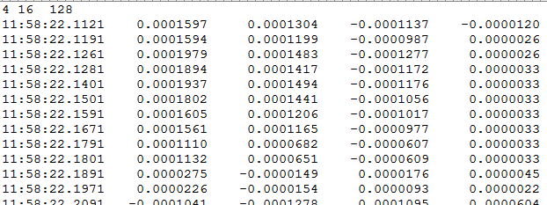
Figure 3: text file
The first line of the text file is the communication parameters: channel numbers, resolution and sample rate. After that, every signal represents one row which consists of the time and signals of four channels.
Because the signals are already in a text file, so a windows program is developed to read this files and send to the client. In this part, the client works as the server of the windows program. They also communicate with TCP protocol. Figure 4 is the structure of the client linked to the real EEG band.

Figure 4: structure of the client linked to the real EEG band
- Simulated EEG Band
For the other clients will read data from the history EEG data. The data are saved in the local disc, so the clients just need to read the local text file and send to the server. The history EEG data have the same structure with the real one.
- Server
Server is aim to handle the operation of the clients and the monitoring program. There are two options to operate the database: read and write. The read option is for the monitoring program. It can receive the request of the monitoring program and read the corresponding data out to. The write option is for the clients. It can receive the data and put them into the database. Both communications are based on TCP.
- Monitoring program
The monitoring program is a Matlab GUI program on windows system. It sends request to the server according to the request of the user. And plot the signal data from the server. It uses TCP to communicate with the server.
- Database Structure
There are three tables in the database: Info (Table 1), Connect Record (Table 2) and Signal Record (Table 3).
Table 1: Info
Field | Type | Format
In_usrno | CT_INT2 | 1,2,3
In_name | CT_STRING | “aa”,”bb”
In_gender | CT_FSTRING | “F”,”M”
In_age | CT_FSTRING | 20,40

Table 2: Connect Record
Field | Type | Format
Cr_usrno | CT_INT2 | 1,2,3
Cr_sequence | CT_INT2 | 1,2,3
Cr_date | CT_DATE | mm/dd/yyyy
Cr_starttime | CT_STRING | hh:mm:ss.sss
Cr_endtime | CT_STRING | hh:mm:ss.sss
Table 3: Signal Record
Field | Type | Format
Sr_usrno | CT_INT2 | 1,2,3
Sr_sequence | CT_INT2 | 1,2,3
Sr_time | CT_DATE | mm/dd/yyyy
Cr_channel1 | CT_STRING | -0.0000802
Cr_channel2 | CT_STRING | -0.0000802
Cr_channel3 | CT_STRING | -0.0000802
Cr_channel4 | CT_STRING | -0.0000802
The “Info” table records the personal information of the user. Every user has an unique user number (“usrno”). It is a pre-existing table before the system running. Every connection to the server needs to check if the user exists at first.
The “Connect Record” table records the sequence and date of connection for each user. Every time the user using the system, a new record will be added in this table to log the connection date, start and end time. The user number is the same as the “Info” table, and the sequence will increase as the number of connection.
The “Signal Record” table is the primary table to record all the signal data. The first two fields are the user number and sequence corresponding to the “Connect Record” table. The remaining five fields are the same as the data in the text file: time and signal of four channels.
- Detailed implementation
- Client
Figure 5 shows the basic flow chart of the client program
Figure 5: flow chart of the client program
The inputs of the client program need to have four parameters: hostname, port, user number and signal type. The hostname and port are used for socket connection with the server. The user number is the identity of the user. The signal type specify whether use the real EEG band or the simulated ones. “0” represents the real EEG and “1”,”2”,”3” specify different history file.
After connecting with the server, they should exchange some essential message. The client first will tell the server it wants to write data. Then it will send the user number and the date to the server. The server will look up the user number in the “Info” table. If the user exists, the server will add a new connect record to the “Connect Record” table and send the confirmation message back to the client. If the user doesn’t exist, the server will send the stop message back to client and close this connection.
Then the program will execute different procedures according to the choice of real EEG or simulated EEG. In real EEG procedure, the program will set up as a server connects with the windows program. After the connection, it will receive the data and send to server. In simulated EEG procedure, the program will read from the text file and send to the server. For the simulated EEG procedure, there is a thread to monitor the input on of the user. If “stop” is typed on the screen, the connection will end.
Every time the client sends data to the server it will wait for the confirm message and then send another data.
- Windows program
The flow char of the windows socket program is showed in Figure 6.
Figure 6: flow chart of the windows program
The windows program will check if the text file exists. After the file created by the EEG program, it then connect to the client. If the file reaches the EOF, the program will sleep 0.5s and read again. Because the sample rate of the EEG is 128, so every 7.8 ms the data should be written to the file. But after some experiments, I found that the data don’t write in the file every 7.8 ms. It seems write to the file after several row of data are acquired. So the 0.5s sleep will not end the procedure before the EEG band really closed. The sleep can check if the EEG connection is really end or just the new data hasn’t been written yet.
- Server
The flow char of the server program is showed in Figure 7.

Figure 7: flow chart of the server program
In the beginning, the program should log onto the Faircom database and open the tables. Then socket is set up to wait for connection. If the connection is request, the server will fork a child process to handle the request. The main process will keep wait for other connections.
After receiving the first message which specify the read or write operation. Two different procedures will be called.
In read procedure, the server will receive the user number and sequence the monitor want to query. Then it will search the “Connect Record” table. If the record doesn’t exist, the error message will send to the monitoring program. Otherwise, the server will send the start time and end time back to the monitoring program. Then it will wait for the time and range the monitoring program want to display. Search these records in the “Signal Records” table and send back. If the records reach to the end before the range reached, the program will also end the connection.
In write procedure, the server will receive the user number as I mentioned before. After query the user number and return the results, the program will add a new record in “Connect Record” table. Then the communication procedure starts. The server receives the data and put into the “Signal Record” database after some processing. For the first signal and the last signal, the program will update the start time and end time in the “Connect Record” table.
When update and write to the database, the write lock will add to the table. So multi clients can write to the database same time.
- Monitoring program
The monitoring program is a Matlab GUI program. Figure 7 shows the interface of the program.
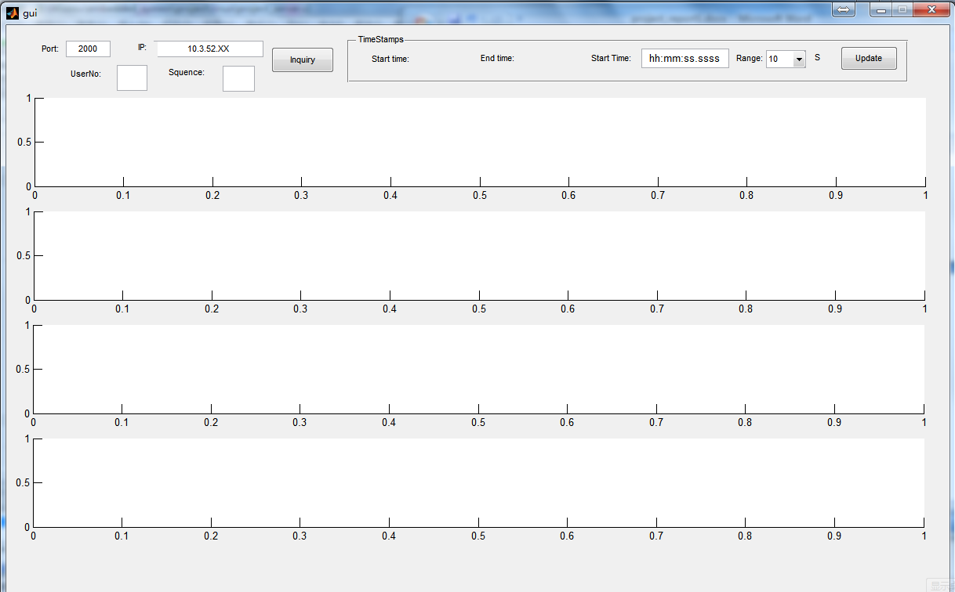
Figure 7: Interface of the monitoring program
On the left top of the interface is the basic setting: port and IP. Under them is the user number and sequence the user wants to check. After filling with these four blanks, the “inquiry” button sets up the TCP and connects to the server.
If the user number and sequence exist, the server will return the start time and end time to static textboxes in the right frame. The user now can choose the start time and the range it want to get. The range can choose from 10 seconds to 60 seconds. Then the “update” button used to send these message to the server and receive the data.
The four channels data then will plot on the bottom axes.
Experiments and Results
- Client to Server (Simulated EEG)
The first test is to send the data to the server using the simulated EEG. The following figures show the results.
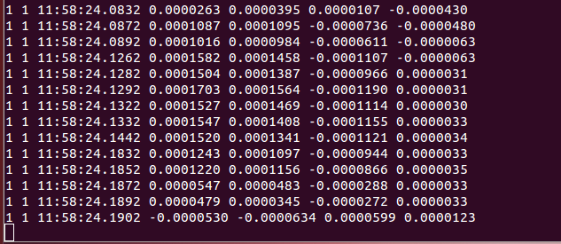
Server
Client
The client chose the user 1 and the text file 1. The last line printed on the client is the head of the text file. It shows that the client can send data to the server.
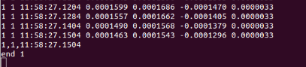
Server
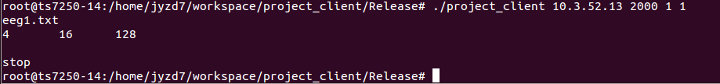
Client
The figures above show that when type “stop” on the client screen, the connection will end. The server prints the end time of the connection.
Now if I print the results in the “Signal Records” database, the data sent before are in it and the “Connect Records” table shows the start and end time. The figure shows below.
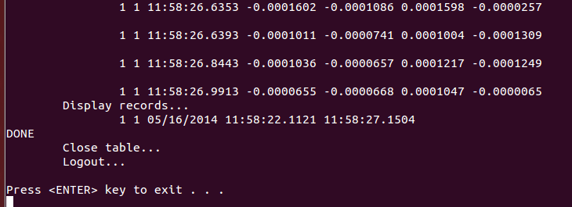
Server
If the client chose the user number doesn’t exist, the server returned the “user doesn’t exist message” and close the connection.
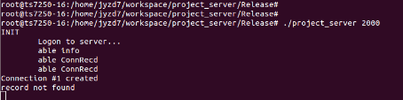
Server
Client
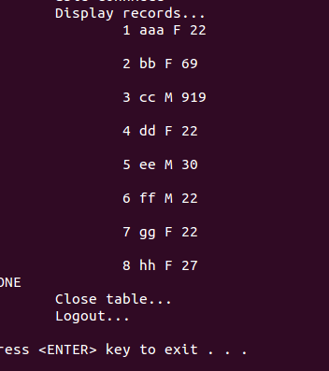
Info table
The following figures shows two clients sent data to the server at the same time.
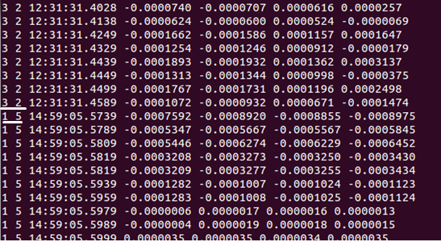
Server
Client 1
Client 2
The client 1 is user 1 and client 2 is user 2. The server displayed both their data.

- Client to Server (Real EEG)
The second serials of tests are to use the real EEG data. Figure 8 is the EEG program interface which is developed by National Chiao Tung University.
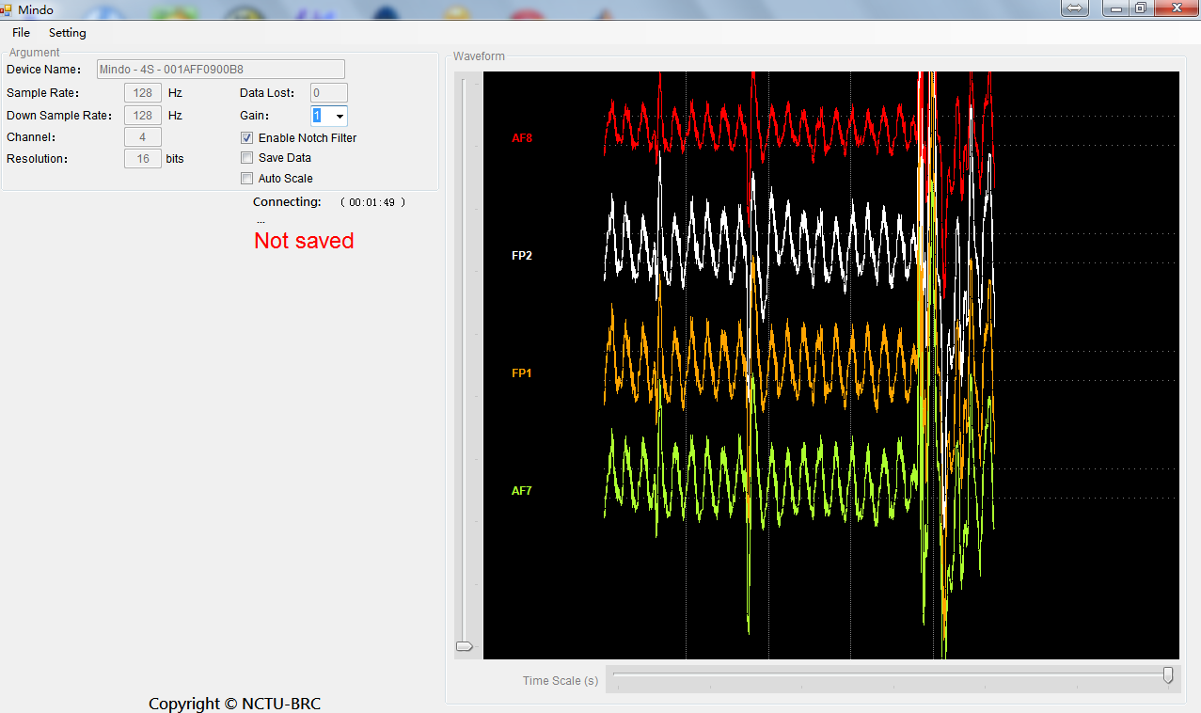
Figure 8: Mindo EEG program
Figure 9 shows that when the text file hadn’t been there, the windows program would not connect to the client.
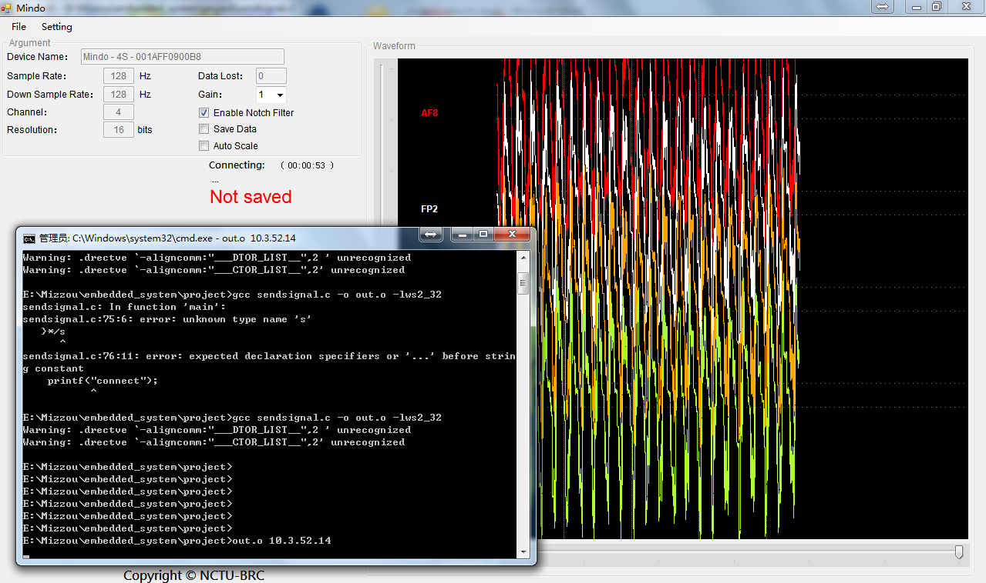
Figure 9: windows program with no file exist
But when the “save data” option checked in the EEG program, the text file was created. Now the windows program started to send data to the client. Figure 10 shows the process.
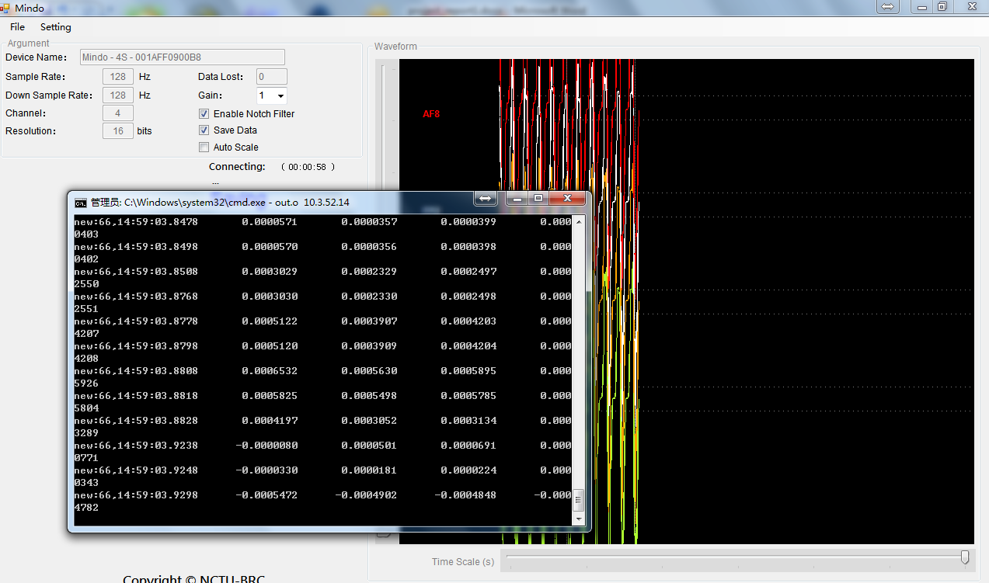
Figure 10: windows program start sending data
The following results show that the client received the data from the windows program and sent them to the server.
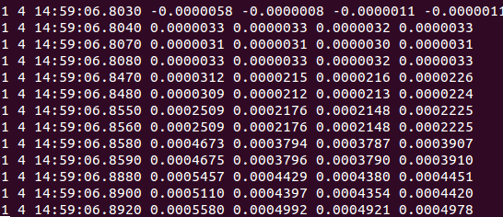
Server
Client
Figure 12 compared the data in the database and the data in the EEG text file. So every data in the EEG text file have been saved in the database.
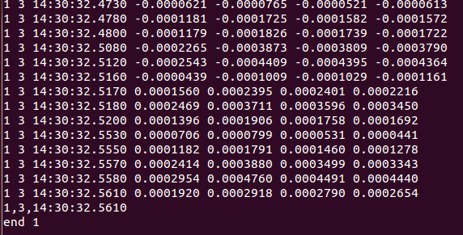
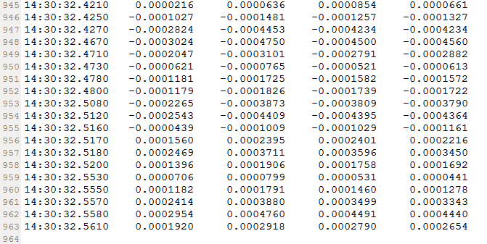
Figure 12: comparison of the database and EEG file
- Monitoring Program
Figure 12 shows the interface when the requested data were sent to the monitoring program and plotted on the interface.
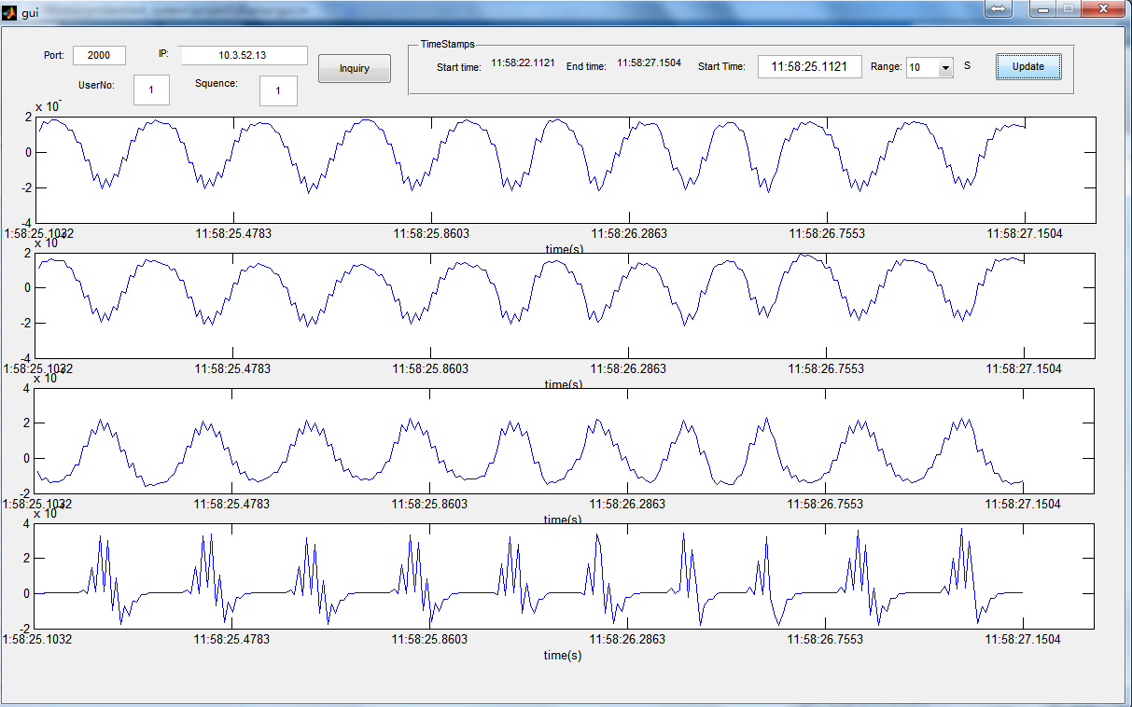
Figure 12: plot data on monitoring program
In this test, the actual existed data was less than the range the user chosen.
Figure 13 shows that the existed data was larger than the range, so it displayed the whole requested range.
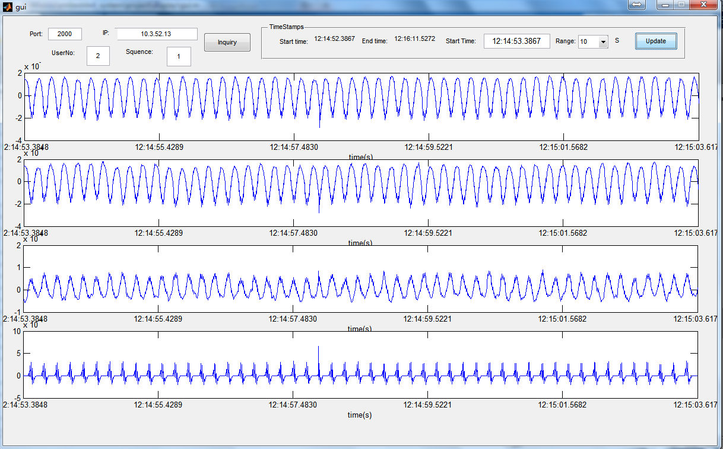
Figure 13: plot data on monitoring program (whole range)
Discussion
The most important thing of this system is that every signal can be saved into the Faircom database. So as I showed in figure 11. The end of the EEG text file is the same as the data in the database. Although because of some limits; the windows program can’t read the text file and send data to the client with the same speed of the EEG program. At least the data are complete.
The reason the windows program can’t synchronize with the EEG program is because I don’t exactly know how the EEG program write data to the text file. I have tried to get the file status. But they don’t changed as expect.
Another way to send the data as fast as possible is to create a circular buffer in the client program. So the main procedure in the client can receive the data and save in the circular buffer, meanwhile a thread is created to handle the data. But because in the situation, the windows program can send data very fast and there will have chance that the data are read not the complete row. That means the EEG program hasn’t written the complete data to the file and the windows program has read them. The problem is as I said above; I don’t really know how the data are written to the file by the EEG program. And the period should be 7.8 ms, but it doesn’t look so. So in this method, there will be lot of wrong data.
As a result, the method I uses now is just use the client to control the speed of the windows program. When the client is ready, tell the windows program and send the data.
Source Code
- Client
#include <stdio.h>
#include <stdlib.h>
#include <unistd.h>
#include <string.h>
#include <sys/types.h>
#include <sys/socket.h>
#include <netinet/in.h>
#include <netdb.h>
#include <arpa/inet.h>
#include <time.h>
#include <rtai_lxrt.h>
#include <pthread.h>

#define MSG_SIZE 68 // message size
int sockfd;

void error(const char *msg)
{
perror(msg);
exit(0);
}

void readfromnetwork(int socksendto)
{
//server to listen
int sockfd, newsockfd, portno;
socklen_t clilen;
struct sockaddr_in serv_addr, cli_addr;
int flag=1;
int n;
char buffer[MSG_SIZE]; //for real signal
char buffer2[MSG_SIZE]; //send to client
char buffer3[MSG_SIZE]; //wait to server

sockfd = socket(AF_INET, SOCK_STREAM, 0); // Creates socket. Connection based.
if (sockfd < 0)
error("ERROR opening socket");

// fill in fields
bzero((char *) &serv_addr, sizeof(serv_addr));
portno = 2050; // get port number from input
serv_addr.sin_family = AF_INET; // symbol constant for Internet domain
serv_addr.sin_addr.s_addr = INADDR_ANY; // IP address of the machine on which
// the server is running
serv_addr.sin_port = htons(portno); // port number

// binds the socket to the address of the host and the port number
if (bind(sockfd, (struct sockaddr *) &serv_addr, sizeof(serv_addr)) < 0)
error("ERROR on binding");

listen(sockfd, 5); // listen for connections
clilen = sizeof(cli_addr); // size of structure
// blocks until a client connects to the server
newsockfd = accept(sockfd, (struct sockaddr *) &cli_addr, &clilen);
close(sockfd);

memset(buffer2,0,MSG_SIZE);
strcpy(buffer2,"go"); //go message tell client to send

while(flag==1)
{
n=read(newsockfd,buffer,MSG_SIZE); //read data
if (n<=0) //if no data end connection
{
flag=0;
close(newsockfd);
}
if (write(socksendto,buffer,MSG_SIZE) < 0) //write to server
{
error("ERROR writing to socket");
}

read(socksendto,buffer2,MSG_SIZE);//block until server reply
write(newsockfd,buffer3,MSG_SIZE); //tell client go

}
fclose(fd);
exit(0);
}

void readfromtxt(FILE *fd,int sockfd,int* stopflag)
{
char buffer[MSG_SIZE];//send
char buffer2[MSG_SIZE]; //receive
//first line is parameter
fgets(buffer,MSG_SIZE,fd);
printf("%s\n",buffer);

bzero(buffer,MSG_SIZE);
while(*stopflag==0 && fgets(buffer,MSG_SIZE,fd)!=NULL) //read every line
{
// send message
if (write(sockfd,buffer,MSG_SIZE) < 0)
error("ERROR writing to socket");
bzero(buffer,MSG_SIZE);

read(sockfd,buffer2,MSG_SIZE);//block until server reply
}
fclose(fd);
exit(0);
}
void *Thread1(void *ptr) //stop the connection is type stop
{
int *stopflag=(int *)ptr;
char buffer[MSG_SIZE];
while(*stopflag==0)
{
fgets(buffer,MSG_SIZE-1,stdin); //check the user type
if(strcmp(buffer,"stop\n")==0)
{
*stopflag=1;
}
}
pthread_exit(NULL);
}

int main(int argc, char *argv[])
{
int portno,n;
struct sockaddr_in serv_addr;
struct hostent *server;
char buffer[MSG_SIZE];

/*get date*/
time_t now;
struct tm *tm_now;
/*txt file*/
FILE *fd;
char txt_name[10];
/*thread*/
pthread_t thread1;
int stopflag;

if (argc < 5) // not enough arguments
{
fprintf(stderr,"usage %s hostname port usrno signal_type\n", argv[0]);
exit(0);
}

portno = atoi(argv[2]); // port # was an input.
sockfd = socket(AF_INET, SOCK_STREAM, 0); // Creates socket. Connection based.
if (sockfd < 0)
error("ERROR opening socket");

server = gethostbyname(argv[1]); // converts hostname input (e.g. 10.3.52.255)
if (server == NULL) {
fprintf(stderr,"ERROR, no such host\n");
exit(0);
}

// fill in fields of serv_addr
bzero((char *) &serv_addr, sizeof(serv_addr)); // sets all values to zero
serv_addr.sin_family = AF_INET; // symbol constant for Internet domain

// copy to serv_addr.sin_addr.s_addr. Function memcpy could be used instead.
bcopy((char *)server->h_addr, (char *)&serv_addr.sin_addr.s_addr, server->h_length);

serv_addr.sin_port = htons(portno); // fill sin_port field

// establish connection to the server
if (connect(sockfd,(struct sockaddr *) &serv_addr,sizeof(serv_addr)) < 0)
error("ERROR connecting");

bzero(buffer,MSG_SIZE);
strcpy(buffer,"write");
write(sockfd,buffer,MSG_SIZE); //tell server it want write

//first message date,usrno
bzero(buffer,MSG_SIZE);
time(&now);
tm_now=localtime(&now);
strftime(buffer,MSG_SIZE,"%m/%d/%Y",tm_now); //date
strcat(buffer,",");
strcat(buffer,argv[3]); //date+usrno
n=write(sockfd,buffer,MSG_SIZE);

//check user no
bzero(buffer,MSG_SIZE);
n=read(sockfd,buffer,MSG_SIZE);
if(strcmp(buffer,"stop")==0)
{
printf("user doesn't exist\n");
close(sockfd);
exit(0);
}

//thread: monitor stop
stopflag=0;
pthread_create(&thread1,NULL,Thread1,(void*)&stopflag);
//open txt
if (atoi(argv[4])==0) //0: real signa,. 1,2,3: txt name
{
readfromnetwork(sockfd); //read from real EEG
}
else
{
sprintf(txt_name,"eeg%s.txt",argv[4]);
printf("%s\n",txt_name);
if((fd=fopen(txt_name,"r"))==NULL)
{
printf("error");
exit(1);
}
readfromtxt(fd,sockfd,&stopflag); //real from Simulated EEG
}

pthread_join(thread1,NULL);
close(sockfd); // close socket
return 0;
}

- Windows program
#include <stdio.h>
#include <stdlib.h>
#include <unistd.h>
#include <string.h>
#include <sys/types.h>
#include <winsock2.h>
#include "stdafx.h"
#include <sys/stat.h>
#include <windows.h>
#pragma comment(lib,"ws2_32.lib") //-lws2_32

#define MSG_SIZE 68 // message size

void error(const char *msg)
{
perror(msg);
exit(0);
}

int main(int argc, char *argv[])
{
int portno, n;
char buffer[MSG_SIZE];
char buffer2[MSG_SIZE];
char buffer3[MSG_SIZE];
char ch;
int t; //waste time
FILE *fd;
int row=0;
int column=0;
//struct stat buf;

if (argc < 2) // not enough arguments
{
fprintf(stderr,"usage %s hostname\n", argv[0]);
exit(0);
}

WORD sockVersion=MAKEWORD(2,2);
WSADATA data;

if(WSAStartup(sockVersion,&data)!=0)
{
return 0;
}

SOCKET sockfd=socket(AF_INET,SOCK_STREAM,IPPROTO_TCP);
if (sockfd==INVALID_SOCKET)
{
printf("invalid socket!");
return 0;
}
struct sockaddr_in serAddr;
serAddr.sin_family=AF_INET;
portno = 2050; // port # 2050
serAddr.sin_port=htons(portno);
serAddr.sin_addr.S_un.S_addr=inet_addr(argv[1]);

//open file
while((fd=fopen("EEG.txt","r"))==NULL)
{ t++;}

// establish connection to the server
if(connect(sockfd,(struct sockaddr *)&serAddr,sizeof(serAddr))==SOCKET_ERROR)
{
printf("connect error!");
closesocket(sockfd);
return 0;
}
printf("connect");

while(1)
{
if(row==0 && fgets(buffer,MSG_SIZE,fd)!=NULL) //the first row don't need to send
{
printf("aa:%s",buffer);
//stat("EEG.txt",&buf);
row++;
}
if(row !=0 )
{
if(fgets(buffer,MSG_SIZE,fd)!=NULL)
{
//stat("EEG.txt",&buf);
printf("new:%d,%s",strlen(buffer),buffer);
// send message
n=send(sockfd,buffer,MSG_SIZE,0);
recv(sockfd,buffer2,MSG_SIZE,0);
row++;
}
else //if EOF wait then check again
{
Sleep(500);
if(fgets(buffer,MSG_SIZE,fd)==NULL)
{ break;} //end send
n=send(sockfd,buffer,MSG_SIZE,0);
recv(sockfd,buffer2,MSG_SIZE,0);
row++;
}
}
}
closesocket(sockfd); // close socket
fclose(fd);
WSACleanup();
return 0;
}

- Server
#ifdef _WIN32_WCE
#undef UNICODE
#undef _UNICODE
#define main my_main
#endif

#include "ctdbsdk.h" /* c-tree headers */
#include <stdio.h>
#include <stdlib.h>
#include <string.h>
#include <unistd.h>
#include <sys/types.h>
#include <sys/socket.h>
#include <netinet/in.h>
#include <netdb.h>
#include <signal.h>
#include <time.h>
#include <rtai_lxrt.h>
#include <sys/ioctl.h>

#define LOCK_SUPPORT /*lock*/

#ifndef ctCLIENT
#ifdef NOTFORCE
#undef LOCK_SUPPORT
#endif
#endif

#define END_OF_FILE INOT_ERR /* INOT_ERR is ctree's 101 error. See cterrc.h */

/* Global declarations */

CTHANDLE hSession;

CTHANDLE hDatabase;

CTHANDLE hTableInfo; //user info: UserNo, name, gender, age
CTHANDLE hTableConnRecd; //record of connection:UserNo, monitor date, start time, end time
CTHANDLE hTableSignalRecd; //record of signal: UserNo, time, channel1, channel2, channel3, channel4

CTHANDLE hRecordInfo;
CTHANDLE hRecordConnRecd;
CTHANDLE hRecordSignalRecd;

/* Function declarations */

#ifdef PROTOTYPE
VOID Initialize(VOID), Define(VOID), Manage(VOID), Done(VOID);

VOID Create_Info_Table(VOID), Create_ConnRecd_Table(VOID);
VOID Create_SignalRecd_Table(VOID);

VOID Add_Info_Records(VOID), Add_ConnRecd_Records(char*,int,int);
VOID Add_SignalRecd_Records(SignalRecd_DATA);

VOID Display_Info(VOID), Display_ConnRecd();
VOID Display_SignalRecd();

VOID Delete_Records(CTHANDLE hRecord);
VOID Check_Table_Mode(CTHANDLE hTable);
VOID update_ConnRecd(CTSTRING,int,int,int);

VOID Handle_Error(CTSTRING);
#else
VOID Initialize(), Define(), Manage(), Done();

VOID Create_Info_Table(), Create_ConnRecd_Table();
VOID Create_SignalRecd_Table();

VOID Add_Info_Records(), Add_ConnRecd_Records();
VOID Add_SignalRecd_Records();

VOID Display_Info(), Display_ConnRecd();
VOID Display_SignalRecd();

VOID Delete_Records();
VOID Check_Table_Mode();
VOID update_ConnRecd()

VOID Handle_Error();
#endif

//server part

#define MSG_SIZE 68 // message size
typedef struct { //signal record data sturcture
COUNT usrno,sequence;
CTSTRING time;
CTSTRING channel1, channel2, channel3, channel4;
} SignalRecd_DATA;
void dostuff(int); // function prototype

void error(const char *msg)
{
perror(msg);
exit(1);
}

//set up server and wait for connection
void start_server(NINT argc,pTEXT argv[])
{
int sockfd, newsockfd, portno, pid, j = 0;
socklen_t clilen;
struct sockaddr_in serv_addr, cli_addr;

if (argc < 2)
{
fprintf(stderr,"ERROR, no port provided\n");
exit(1);
}

sockfd = socket(AF_INET, SOCK_STREAM, 0); // Creates socket. Connection based.
if (sockfd < 0)
error("ERROR opening socket");

// fill in fields
bzero((char *) &serv_addr, sizeof(serv_addr));
portno = atoi(argv[1]); // get port number from input
serv_addr.sin_family = AF_INET; // symbol constant for Internet domain
serv_addr.sin_addr.s_addr = INADDR_ANY; // IP address of the machine on which
// the server is running
serv_addr.sin_port = htons(portno); // port number

// binds the socket to the address of the host and the port number
if (bind(sockfd, (struct sockaddr *) &serv_addr, sizeof(serv_addr)) < 0)
error("ERROR on binding");

listen(sockfd, 5); // listen for connections
clilen = sizeof(cli_addr); // size of structure

while (1)
{
// blocks until a client connects to the server
newsockfd = accept(sockfd, (struct sockaddr *) &cli_addr, &clilen);
if (newsockfd < 0)
error("ERROR on accept");

j++; // counter for the connections that are established.
pid = fork();
if (pid < 0)
error("ERROR on fork");

if (pid == 0) // child process
{
printf("Connection #%d created\n",j);
close(sockfd); // close socket
dostuff(newsockfd); // call function that handles communication
printf("end %d\n",j);
exit(0);

}
else // parent
{
close(newsockfd);
signal(SIGCHLD,SIG_IGN); // to avoid zombie problem
}
} // end of while

close(sockfd);

}

/*
* main()
*
* The main() function implements the concept of "init, define, manage
* and you're done..."
*/

#ifdef PROTOTYPE
NINT main (NINT argc, pTEXT argv[])
#else
NINT main (argc, argv)
NINT argc;
TEXT argv[];
#endif
{

Initialize(); //link to faircom

Define(); //create or open tables

//socket
start_server(argc,argv);

//use it and choose the function in manage to delete or display the table
//Manage();

Done();

printf("\nPress <ENTER> key to exit . . .\n");
#ifndef ctPortWINCE
getchar();
#endif

return(0);
}

/*
* Initialize()
*
* Perform the minimum requirement of logging onto the c-tree Server
*/

#ifdef PROTOTYPE
VOID Initialize(VOID)
#else
VOID Initialize()
#endif
{
CTDBRET retval;

printf("INIT\n");

if ((retval = ctdbStartDatabaseEngine())) /* This function is required when you are using the Server DLL model to start the underlying Server. */
Handle_Error("Initialize(): ctdbStartDatabaseEngine()"); /* It does nothing in all other c-tree models */

/* allocate session handle */
if ((hSession = ctdbAllocSession(CTSESSION_CTREE)) == NULL)
Handle_Error("Initialize(): ctdbAllocSession()");

hDatabase = hSession;

/* connect to server */
printf("\tLogon to server...\n");
if (ctdbLogon(hSession, "FAIRCOMS", "ADMIN", "ADMIN"))
Handle_Error("Initialize(): ctdbLogon()");

}

/*
* Define()
*
* Open the table, if it exists. Otherwise create and open the table
*/

#ifdef PROTOTYPE
VOID Define(VOID)
#else
VOID Define()
#endif
{
//3 tables
Create_Info_Table();
Create_ConnRecd_Table();
Create_SignalRecd_Table();

if ((hRecordInfo = ctdbAllocRecord(hTableInfo)) == NULL)
Handle_Error("Add_Info_Records(): ctdbAllocRecord()");
if ((hRecordConnRecd = ctdbAllocRecord(hTableConnRecd)) == NULL)
Handle_Error("Add_ConnRecd_Records(): ctdbAllocRecord()");
if ((hRecordSignalRecd = ctdbAllocRecord(hTableSignalRecd)) == NULL)
Handle_Error("Add_SignalRecd_Records(): ctdbAllocRecord()");
}

/*
* Manage()
*
* This function performs simple record functions of add, delete and gets
*/

#ifdef PROTOTYPE
VOID Manage(VOID)
#else
VOID Manage()
#endif
{

//Delete_Records(hRecordInfo);
//Delete_Records(hRecordConnRecd);
//Delete_Records(hRecordSignalRecd);

//Add_Info_Records();

//Display_Info();
//Display_ConnRecd();
//Display_SignalRecd();

}

/*
* Done()
*
* This function handles the housekeeping of closing tables and
* freeing of associated memory
*/

#ifdef PROTOTYPE
VOID Done(VOID)
#else
VOID Done()
#endif
{
printf("DONE\n");

/* close table */
printf("\tClose table...\n");
if (ctdbCloseTable(hTableInfo))
Handle_Error("Done(): ctdbCloseTable()");
if (ctdbCloseTable(hTableConnRecd))
Handle_Error("Done(): ctdbCloseTable()");
if (ctdbCloseTable(hTableSignalRecd))
Handle_Error("Done(): ctdbCloseTable()");

/* logout */
printf("\tLogout...\n");
if (ctdbLogout(hSession))
Handle_Error("Done(): ctdbLogout()");

/* free handles */
ctdbFreeRecord(hRecordInfo);
ctdbFreeRecord(hRecordConnRecd);
ctdbFreeRecord(hRecordSignalRecd);

ctdbFreeTable(hTableInfo);
ctdbFreeTable(hTableConnRecd);
ctdbFreeTable(hTableSignalRecd);

ctdbFreeSession(hSession);

/* If you are linked to the Server DLL, then we should stop our Server at the end of the program. */
/* It does nothing in all other c-tree models */
ctdbStopDatabaseEngine();
}

/*
* Create_Create_Info_Table_Table()
*
* Open table Info, if it exists. Otherwise create it
* along with its indices and open it
*/

#ifdef PROTOTYPE
VOID Create_Info_Table(VOID)
#else
VOID Create_Info_Table()
#endif
{
CTHANDLE pField1, pField2, pField3, pField4;
CTHANDLE pIndex;
CTHANDLE pIseg;

/* define table CustomerMaster */
printf("\table info\n");

/* allocate a table handle */
if ((hTableInfo = ctdbAllocTable(hDatabase)) == NULL)
Handle_Error("Create_info_Table(): ctdbAllocTable()");

/* open table */
if (ctdbOpenTable(hTableInfo, "UserInfo", CTOPEN_NORMAL))
{
/* define table fields */
pField1 = ctdbAddField(hTableInfo, "In_userno", CT_INT2, 2);
pField2 = ctdbAddField(hTableInfo, "In_name", CT_STRING, 47);
pField3 = ctdbAddField(hTableInfo, "In_gender", CT_FSTRING, 1);
pField4 = ctdbAddField(hTableInfo, "In_age", CT_FSTRING, 3);

if (!pField1 || !pField2 || !pField3 || !pField4 )
Handle_Error("Create_CustomerMaster_Table(): ctdbAddField()");

/* define index . usrno*/
pIndex = ctdbAddIndex(hTableInfo, "in_userno_idx", CTINDEX_PADDING, NO, NO);
pIseg = ctdbAddSegment(pIndex, pField1, CTSEG_SCHSEG);
if (!pIndex || !pIseg)
Handle_Error("Create_CustomerMaster_Table(): ctdbAddIndex()|ctdbAddSegment()");

/* create table */
if (ctdbCreateTable(hTableInfo, "UserInfo", CTCREATE_NORMAL))
Handle_Error("Create_CustomerMaster_Table(): ctdbCreateTable()");

/* open table */
if (ctdbOpenTable(hTableInfo, "UserInfo", CTOPEN_NORMAL))
Handle_Error("Create_CustomerMaster_Table(): ctdbOpenTable()");
}
else
{
Check_Table_Mode(hTableInfo);

}
}

/*
* Create_Create_ConnRecd_Table_Table()
*
* Open table ConnRecd, if it exists. Otherwise create it
* along with its indices and open it
*/

#ifdef PROTOTYPE
VOID Create_ConnRecd_Table(VOID)
#else
VOID Create_ConnRecd_Table()
#endif
{
CTHANDLE pField1, pField2, pField3, pField4,pField5;
CTHANDLE pIndex1,pIndex2;
CTHANDLE pIseg1,pIseg2,pIseg3;

/* define table CustomerMaster */
printf("\table ConnRecd\n");

/* allocate a table handle */
if ((hTableConnRecd = ctdbAllocTable(hDatabase)) == NULL)
Handle_Error("Create_ConnRecd_Table(): ctdbAllocTable()");

/* open table */
if (ctdbOpenTable(hTableConnRecd, "ConnRecd", CTOPEN_NORMAL))
{
/* define table fields */
pField1 = ctdbAddField(hTableConnRecd, "Cr_userno", CT_INT2, 2);
pField2 = ctdbAddField(hTableConnRecd, "Cr_sequence", CT_INT2, 2);
pField3 = ctdbAddField(hTableConnRecd, "Cr_date", CT_DATE, 4);
pField4 = ctdbAddField(hTableConnRecd, "Cr_starttime", CT_FSTRING, 13);
pField5 = ctdbAddField(hTableConnRecd, "Cr_endtime", CT_FSTRING, 13);

if (!pField1 || !pField2 || !pField3 || !pField4 )
Handle_Error("Create_ConnRecd_Table(): ctdbAddField()");

/* define index usrno can be dupliex*/
pIndex1 = ctdbAddIndex(hTableConnRecd, "cr_userno_idx", CTINDEX_PADDING, YES, NO);
pIseg1 = ctdbAddSegment(pIndex1, pField1, CTSEG_SCHSEG);
//usrno and sequence, can't be dupliex
pIndex2 = ctdbAddIndex(hTableConnRecd, "cr_usersequence_idx", CTINDEX_PADDING, NO, NO);
pIseg2 = ctdbAddSegment(pIndex2, pField1, CTSEG_SCHSEG);
pIseg3 = ctdbAddSegment(pIndex2, pField2, CTSEG_SCHSEG);

if (!pIndex1 || !pIndex2 || !pIseg1 || !pIseg2 || !pIseg3)
Handle_Error("Create_ConnRecd_Table(): ctdbAddIndex()|ctdbAddSegment()");

/* create table */
if (ctdbCreateTable(hTableConnRecd, "ConnRecd", CTCREATE_NORMAL))
Handle_Error("Create_ConnRecd_Table(): ctdbCreateTable()");

/* open table */
if (ctdbOpenTable(hTableConnRecd, "ConnRecd", CTOPEN_NORMAL))
Handle_Error("Create_ConnRecd_Table(): ctdbOpenTable()");
}
else
{
Check_Table_Mode(hTableConnRecd);

}
}

/*
* Create_Create_SignalRecd_Table_Table()
*
* Open table SignalRecd, if it exists. Otherwise create it
* along with its indices and open it
*/

#ifdef PROTOTYPE
VOID Create_SignalRecd_Table(VOID)
#else
VOID Create_SignalRecd_Table()
#endif
{
CTHANDLE pField1, pField2, pField3, pField4;
CTHANDLE pField5, pField6, pField7;
CTHANDLE pIndex1,pIndex2;
CTHANDLE pIseg1,pIseg2,pIseg3,pIseg4,pIseg5;

/* define table CustomerMaster */
printf("\table ConnRecd\n");

/* allocate a table handle */
if ((hTableSignalRecd = ctdbAllocTable(hDatabase)) == NULL)
Handle_Error("Create_SignalRecd_Table(): ctdbAllocTable()");

/* open table */
if (ctdbOpenTable(hTableSignalRecd, "SignalRecd", CTOPEN_NORMAL))
{

/* define table fields */
pField1 = ctdbAddField(hTableSignalRecd, "Sr_userno", CT_INT2, 2);
pField2 = ctdbAddField(hTableSignalRecd, "Sr_sequence", CT_INT2, 2);
pField3 = ctdbAddField(hTableSignalRecd, "Sr_time", CT_FSTRING, 13);
pField4 = ctdbAddField(hTableSignalRecd, "Sr_channel1", CT_STRING, 11);
pField5 = ctdbAddField(hTableSignalRecd, "Sr_channel2", CT_STRING, 11);
pField6 = ctdbAddField(hTableSignalRecd, "Sr_channel3", CT_STRING, 11);
pField7 = ctdbAddField(hTableSignalRecd, "Sr_channel4", CT_STRING, 11);

if (!pField1 || !pField2 || !pField3 || !pField4 || !pField5|| !pField6|| !pField7)
Handle_Error("Create_SignalRecd_Table(): ctdbAddField()");

/* define index usrno and sequence can be dupliex*/
pIndex1 = ctdbAddIndex(hTableSignalRecd, "sr_usersequence_idx", CTINDEX_PADDING, YES, NO);
pIseg1 = ctdbAddSegment(pIndex1, pField1, CTSEG_SCHSEG);
pIseg2 = ctdbAddSegment(pIndex1, pField2, CTSEG_SCHSEG);
//usrno sequence and time can't be dupliex
pIndex2 = ctdbAddIndex(hTableSignalRecd, "sr_seqtime_idx", CTINDEX_PADDING, NO, NO);
pIseg3 = ctdbAddSegment(pIndex2, pField1, CTSEG_DESCENDING);//time is in descending mode
pIseg4 = ctdbAddSegment(pIndex2, pField2, CTSEG_DESCENDING);//so the display time will be in order
pIseg5 = ctdbAddSegment(pIndex2, pField3, CTSEG_DESCENDING);

if (!pIndex1 || !pIseg1 || !pIseg2 ||!pIndex2|| !pIseg3|| !pIseg4|| !pIseg5)
Handle_Error("Create_ConnRecd_Table(): ctdbAddIndex()|ctdbAddSegment()");

/* create table */
if (ctdbCreateTable(hTableSignalRecd, "SignalRecd", CTCREATE_NORMAL))
Handle_Error("Create_SignalRecd_Table(): ctdbCreateTable()");

/* open table */
if (ctdbOpenTable(hTableSignalRecd, "SignalRecd", CTOPEN_NORMAL))
Handle_Error("Create_SignalRecd_Table(): ctdbOpenTable()");
}
else
{
Check_Table_Mode(hTableSignalRecd);

}
}

/*
* Check_Table_Mode()
*
* Check if existing table has transaction processing flag enabled.
* If a table is under transaction processing control, modify the
* table mode to disable transaction processing
*/

#ifdef PROTOTYPE
VOID Check_Table_Mode(CTHANDLE hTable)
#else
VOID Check_Table_Mode(hTable)
CTHANDLE hTable;
#endif
{
CTCREATE_MODE mode;

/* get table create mode */
mode = ctdbGetTableCreateMode(hTable);

/* check if table is under transaction processing control */
if ((mode & CTCREATE_TRNLOG))
{
/* change file mode to disable transaction processing */
mode ^= CTCREATE_TRNLOG;
if (ctdbUpdateCreateMode(hTable, mode) != CTDBRET_OK)
Handle_Error("Check_Table_Mode(); ctdbUpdateCreateMode");
}
}

/*
* Delete_Records()
*
* This function deletes all the records in the table
*/

#ifdef PROTOTYPE
VOID Delete_Records(CTHANDLE hRecord)
#else
VOID Delete_Records(hRecord)
CTHANDLE hRecord;
#endif
{
CTDBRET retval;
CTBOOL empty;

printf("\tDelete records...\n");

/* enable session-wide lock flag */
if (ctdbLock(hSession, CTLOCK_WRITE_BLOCK))
Handle_Error("Delete_Records(): ctdbLock()");

empty = NO;
retval = ctdbFirstRecord(hRecord);
if (retval != CTDBRET_OK)
{
if (retval == END_OF_FILE)
empty = YES;
else
Handle_Error("Delete_Records(): ctdbFirstRecord()");
}

while (empty == NO) /* while table is not empty */
{
/* delete record */
if (ctdbDeleteRecord(hRecord))
Handle_Error("Delete_Records(): ctdbDeleteRecord()");

/* read next record */
retval = ctdbNextRecord(hRecord);
if (retval != CTDBRET_OK)
{
if (retval == END_OF_FILE)
empty = YES;
else
Handle_Error("Delete_Records(): ctdbNextRecord()");
}
}
if (ctdbUnlock(hSession))
Handle_Error("Delete_Records(): ctdbLock()");
}
/*
* Add_Info_Records()
*
* This function adds Info_Records to a table in the database
*/

typedef struct {
COUNT usrno;
CTSTRING name,gender,age;
} INFO_DATA;

INFO_DATA data1[]=
{{1, "aaa", "F", "22"},{2, "bb", "F", "69"},{3, "cc", "M", "919"},{4, "dd", "F", "22"},
{5, "ee", "M", "30"},{6, "ff", "M", "22"},{7, "gg", "F", "22"},{8, "hh", "F", "27"}
}; //pre-exist records

#ifdef PROTOTYPE
VOID Add_Info_Records(VOID)
#else
VOID Add_Info_Records()
#endif
{
CTDBRET retval;
CTSIGNED i;
CTSIGNED nRecords = sizeof(data1) / sizeof(INFO_DATA);

printf("\tAdd records...\n");
/* add data to table */

//Delete_Records(hRecordInfo);

for (i=0;i<nRecords;i++)
{
/* clear record buffer */
ctdbClearRecord(hRecordInfo);

retval = 0;
/* populate record buffer with data */
retval |= ctdbSetFieldAsSigned(hRecordInfo, 0, data1[i].usrno);
retval |= ctdbSetFieldAsString(hRecordInfo, 1, data1[i].name);
retval |= ctdbSetFieldAsString(hRecordInfo, 2, data1[i].gender);
retval |= ctdbSetFieldAsString(hRecordInfo, 3, data1[i].age);

if (retval)
Handle_Error("Add_hRecordInfo(): ctdbSetFieldAsString()");

/* add record */
if (ctdbWriteRecord(hRecordInfo))
printf("Add_hRecordInfo(): ctdbWriteRecord()");
//Handle_Error("Add_hRecordInfo(): ctdbWriteRecord()");
}
}

/*
* Add_ConnRecd_Records()
*
* This function adds ConnRecd records to a table in the database
*/

typedef struct {
COUNT usrno,sequence;
CTSTRING date,starttime,endtime;
} ConnRecd_DATA;

#ifdef PROTOTYPE
VOID Add_ConnRecd_Records(char* date_string ,int usrno ,int sequence)
#else
VOID Add_ConnRecd_Records()
#endif
{
CTDBRET retval;
CTDATE date;

ConnRecd_DATA data2;
data2.usrno=usrno;
data2.sequence=sequence;
data2.starttime=""; //at first no start and end time
data2.endtime="";

printf("\tAdd records...\n");
/* add data to table */

/* clear record buffer */
ctdbClearRecord(hRecordConnRecd);

retval = 0;
retval |= ctdbStringToDate(date_string, CTDATE_MDCY ,&date); //convert to data type
/* populate record buffer with data */
retval |= ctdbSetFieldAsSigned(hRecordConnRecd, 0, data2.usrno);
retval |= ctdbSetFieldAsSigned(hRecordConnRecd, 1,data2.sequence);
retval |= ctdbSetFieldAsDate(hRecordConnRecd, 2, date);
retval |= ctdbSetFieldAsString(hRecordConnRecd, 3, data2.starttime);
retval |= ctdbSetFieldAsString(hRecordConnRecd, 4, data2.endtime);

if (retval)
Handle_Error("Add_hRecordConnRecd(): ctdbSetFieldAsString()");

ctdbLock(hTableConnRecd, CTLOCK_WRITE_BLOCK); //tablelock
if (ctdbWriteRecord(hRecordConnRecd))
printf("Add_hRecordConnRecd(): ctdbWriteRecord()");

ctdbUnlockTable(hTableConnRecd);
}

/*
* Add_SignalRecd_Records()
*
* This function adds signal records to a table in the database
*/

#ifdef PROTOTYPE
VOID Add_SignalRecd_Records(SignalRecd_DATA data3)
#else
VOID Add_SignalRecd_Records()
#endif
{
CTDBRET retval;

printf("%d %d %s %s %s %s %s\n",data3.usrno,data3.sequence,data3.time,data3.channel1,
data3.channel2,data3.channel3,data3.channel4);

/* add data to table */

/* clear record buffer */
ctdbClearRecord(hRecordSignalRecd);

retval = 0;
/* populate record buffer with data */
retval |= ctdbSetFieldAsSigned(hRecordSignalRecd, 0, data3.usrno);
retval |= ctdbSetFieldAsSigned(hRecordSignalRecd, 1, data3.sequence);
retval |= ctdbSetFieldAsString(hRecordSignalRecd, 2, data3.time);
retval |= ctdbSetFieldAsString(hRecordSignalRecd, 3, data3.channel1);
retval |= ctdbSetFieldAsString(hRecordSignalRecd, 4, data3.channel2);
retval |= ctdbSetFieldAsString(hRecordSignalRecd, 5, data3.channel3);
retval |= ctdbSetFieldAsString(hRecordSignalRecd, 6, data3.channel4);

if (retval)
Handle_Error("Add_hRecordSignalRecd(): ctdbSetFieldAsString()");

//lock and write
ctdbLock(hTableSignalRecd, CTLOCK_WRITE_BLOCK);

ctdbWriteRecord(hRecordSignalRecd);

ctdbUnlockTable(hTableSignalRecd);

}

/*
* Display_Info()
*
* This function displays the contents of a table. ctdbFirstRecord() and
* ctdbNextRecord() fetch the record. Then each field is parsed and displayed
*/

#ifdef PROTOTYPE
VOID Display_Info(VOID)
#else
VOID Display_Info()
#endif
{
CTDBRET retval;
CTSIGNED usrno;
TEXT name[47+1];
TEXT gender[1+1];
TEXT age[3+1];

printf("\tDisplay records...");

/* read first record */
retval = ctdbFirstRecord(hRecordInfo);
if (retval != CTDBRET_OK)
Handle_Error("Display_hRecordInfo(): ctdbFirstRecord()");

while (retval != END_OF_FILE)
{
retval = 0;
retval |= ctdbGetFieldAsSigned(hRecordInfo, 0, &usrno);
retval |= ctdbGetFieldAsString(hRecordInfo, 1, name, sizeof(name));
retval |= ctdbGetFieldAsString(hRecordInfo, 2, gender, sizeof(gender));
retval |= ctdbGetFieldAsString(hRecordInfo, 3, age, sizeof(age));

if (retval)
Handle_Error("Display_hRecordInfo(): ctdbGetFieldAsString()");

printf("\n\t\t%lu %s %s %s\n",usrno, name,gender,age);

/* read next record */
retval = ctdbNextRecord(hRecordInfo);
if (retval == END_OF_FILE)
break; /* reached end of file */

if (retval != CTDBRET_OK)
Handle_Error("Display_hRecordInfo(): ctdbNextRecord()");
}
}

/*
* Display_ConnRecd()
*
* This function displays the contents of a table. ctdbFirstRecord() and
* ctdbNextRecord() fetch the record. Then each field is parsed and displayed
*/

#ifdef PROTOTYPE
VOID Display_ConnRecd()
#else
VOID Display_ConnRecd()
#endif
{
CTDBRET retval;
CTSIGNED usrno;
CTSIGNED sequence;
CTDATE date;
TEXT date_s[10+1];
TEXT starttime[13+1];
TEXT endtime[13+1];

printf("\tDisplay records...");

/* read first record */
retval = ctdbFirstRecord(hRecordConnRecd);
if (retval != CTDBRET_OK)
Handle_Error("Display_hRecordConnRecd(): ctdbFirstRecord()");

while (retval != END_OF_FILE)
{
retval = 0;
retval |= ctdbGetFieldAsSigned(hRecordConnRecd, 0, &usrno);
retval |= ctdbGetFieldAsSigned(hRecordConnRecd, 1, &sequence);
retval |= ctdbGetFieldAsDate(hRecordConnRecd, 2, &date);
retval |= ctdbGetFieldAsString(hRecordConnRecd, 3, starttime, sizeof(starttime));
retval |= ctdbGetFieldAsString(hRecordConnRecd, 4, endtime, sizeof(endtime));

/* convert date to vision type*/
retval |= ctdbDateToString(date, CTDATE_MDCY, date_s,sizeof(date_s));

if (retval)
Handle_Error("Display_hRecordConnRecd(): ctdbGetFieldAsString()");

printf("\n\t\t%lu %lu %s %s %s\n",usrno,sequence,date_s,starttime,endtime);

/* read next record */
retval = ctdbNextRecord(hRecordConnRecd);
if (retval == END_OF_FILE)
break; /* reached end of file */

if (retval != CTDBRET_OK)
Handle_Error("Display_hRecordConnRecd(): ctdbNextRecord()");
}
}

/*
* Display_SignalRecd();()
*
* This function displays the contents of a table. ctdbFirstRecord() and
* ctdbNextRecord() fetch the record. Then each field is parsed and displayed
*/

#ifdef PROTOTYPE
VOID Display_SignalRecd()
#else
VOID Display_SignalRecd()
#endif
{
CTDBRET retval=CTDBRET_OK;
CTSIGNED usrno;
CTSIGNED sequence;
TEXT time[13+1];
TEXT channel1[11+1];
TEXT channel2[11+1];
TEXT channel3[11+1];
TEXT channel4[11+1];

printf("\tDisplay records...");

/* read first record */
retval = ctdbFirstRecord(hRecordSignalRecd);
if (retval != CTDBRET_OK)
Handle_Error("Display_hRecordSignalRecd(): ctdbFirstRecord()");

while (retval != END_OF_FILE)
{
retval = 0;
retval |= ctdbGetFieldAsSigned(hRecordSignalRecd, 0, &usrno);
retval |= ctdbGetFieldAsSigned(hRecordSignalRecd, 1, &sequence);
retval |= ctdbGetFieldAsString(hRecordSignalRecd, 2, time, sizeof(time));
retval |= ctdbGetFieldAsString(hRecordSignalRecd, 3, channel1,sizeof(channel1));
retval |= ctdbGetFieldAsString(hRecordSignalRecd, 4, channel2,sizeof(channel2));
retval |= ctdbGetFieldAsString(hRecordSignalRecd, 5, channel3,sizeof(channel3));
retval |= ctdbGetFieldAsString(hRecordSignalRecd, 6, channel4,sizeof(channel4));

if (retval)
Handle_Error("Display_hRecordSignalRecd(): ctdbGetFieldAsString()");

printf("\n\t\t%lu %lu %s %s %s %s %s\n",usrno,sequence,time,channel1,channel2,channel3,channel4);

/* read next record */
retval = ctdbNextRecord(hRecordSignalRecd);
if (retval == END_OF_FILE)
break; /* reached end of file */

if (retval != CTDBRET_OK)
Handle_Error("Display_hRecordSignalRecd(): ctdbNextRecord()");
}
}

/*
* Handle_Error()
*
* This function is a common bailout routine. It displays an error message
* allowing the user to acknowledge before terminating the application
*/

#ifdef PROTOTYPE
VOID Handle_Error(CTSTRING errmsg)
#else
VOID Handle_Error(errmsg)
CTSTRING errmsg;
#endif
{
printf("\nERROR: [%d] - %s \n", ctdbGetError(hSession), errmsg);
printf("*** Execution aborted *** \nPress <ENTER> key to exit...");

ctdbLogout(hSession);

ctdbFreeRecord(hRecordInfo);
ctdbFreeRecord(hRecordConnRecd);
ctdbFreeRecord(hRecordSignalRecd);

ctdbFreeTable(hTableInfo);
ctdbFreeTable(hTableConnRecd);
ctdbFreeTable(hTableSignalRecd);

ctdbFreeSession(hSession);

getchar();

exit(1);
}

/*updat the connect start time and end time. at the begining and end of the transfer*/
void update_ConnRecd(CTSTRING time,int fieldNum,int usrno,int sequence)
{
printf("%d,%d,%s\n",usrno,sequence,time);
if(ctdbClearRecord(hRecordConnRecd))//clear record handle
Handle_Error("update");
if(ctdbSetDefaultIndex(hRecordConnRecd,1)) //set index
Handle_Error("check_usrno():ctdbSetDefaultIndex");
if(ctdbSetFieldAsSigned(hRecordConnRecd,0,usrno))
Handle_Error("check_usrno():ctdbSetFieldAsSigned");
if(ctdbSetFieldAsSigned(hRecordConnRecd,1,sequence))
Handle_Error("check_usrno():ctdbSetFieldAsSigned");
if(ctdbFindRecord(hRecordConnRecd,CTFIND_EQ)!=CTDBRET_OK) //quire
printf("record not found\n");
else //find record
{
ctdbLockRecord(hRecordConnRecd, CTLOCK_WRITE_BLOCK);

if(ctdbSetFieldAsString(hRecordConnRecd,fieldNum,time))
Handle_Error("update:set");
if(ctdbWriteRecord(hRecordConnRecd)!=CTDBRET_OK)//update
Handle_Error("update:write");

ctdbUnlockRecord(hRecordConnRecd);

}
}

/*check if usrno exist in info table. call at the begining of the connection*/
int check_usrno(int usrno)
{
int usr_check=0; //check if usrno exist. 0: no, 1: yes
if(ctdbClearRecord(hRecordInfo))
Handle_Error("check_usrno():ctdbClearRecord");
if(ctdbSetFieldAsSigned(hRecordInfo,0,usrno))
Handle_Error("check_usrno():ctdbSetFieldAsSigned");
if(ctdbFindRecord(hRecordInfo,CTFIND_EQ)!=CTDBRET_OK)//find
printf("record not found\n");
else
usr_check=1; //found record

return usr_check;
}

/*check which sequence is this time*/
int check_sequence(int usrno)
{
CTDBRET retval;
CTSIGNED t_sequence; //sequence of usrno in table connect record
int sequence=0; //
CTBOOL old_usr; //there are records related to this user
if(ctdbClearRecord(hRecordConnRecd))
Handle_Error("check_sequence():ctdbClearRecord");
if(ctdbSetFieldAsSigned(hRecordConnRecd,0,usrno))
Handle_Error("check_sequence():ctdbSetFieldAsSigned");
if(ctdbRecordSetOn(hRecordConnRecd,2)) //create set. because one user can have more
//than one connection record
Handle_Error("check_sequence():ctdbRecordSetOn");
else
{
if(ctdbFirstRecord(hRecordConnRecd))
{
sequence=0; //found record;
}
else
{
old_usr=YES;
while(old_usr)
{
sequence++; //count sequence
if(ctdbGetFieldAsSigned(hRecordConnRecd,1,&t_sequence))
Handle_Error("check_sequence():ctdbGetFieldAsSigned");
//read next record
retval=ctdbNextRecord(hRecordConnRecd);
if(retval!=CTDBRET_OK)
{
if(retval==END_OF_FILE)
old_usr=NO;
else
Handle_Error("check_sequence():ctdbNextRecord");
}
}
ctdbRecordSetOff(hRecordConnRecd);
}

}
return sequence;
}

/*send signal to monitoring program*/
VOID Send_SignalRecd(CTHANDLE hRecordSignalRecd,int sendsock,int send_num,int s_usrno,int s_sequence)
{
CTDBRET retval=CTDBRET_OK;
CTSIGNED usrno;
CTSIGNED sequence;
TEXT time[13+1];
TEXT channel1[11+1];
TEXT channel2[11+1];
TEXT channel3[11+1];
TEXT channel4[11+1];
char buffer[MSG_SIZE]; //data
char buffer2[MSG_SIZE]; //receive confirm message
char buffer3[MSG_SIZE]; //send confirm message
int n,i=0;

memset(buffer3,0,MSG_SIZE);
strcpy(buffer3,"y"); //confirm message

while (i<send_num) //if not reach the data within the time range
{
ctdbLock(hTableSignalRecd, CTLOCK_SUSPEND); //suspend lock
retval = 0;
retval |= ctdbGetFieldAsSigned(hRecordSignalRecd, 0, &usrno);
retval |= ctdbGetFieldAsSigned(hRecordSignalRecd, 1, &sequence);
retval |= ctdbGetFieldAsString(hRecordSignalRecd, 2, time, sizeof(time));
retval |= ctdbGetFieldAsString(hRecordSignalRecd, 3, channel1,sizeof(channel1));
retval |= ctdbGetFieldAsString(hRecordSignalRecd, 4, channel2,sizeof(channel2));
retval |= ctdbGetFieldAsString(hRecordSignalRecd, 5, channel3,sizeof(channel3));
retval |= ctdbGetFieldAsString(hRecordSignalRecd, 6, channel4,sizeof(channel4));
ctdbLock(hTableSignalRecd, CTLOCK_WRITE_BLOCK);

if (retval)
Handle_Error("Display_hRecordSignalRecd(): ctdbGetFieldAsString()");
//determine usrno sequence
if(usrno!=s_usrno || sequence!= s_sequence)
{
memset(buffer3,0,MSG_SIZE);
strcpy(buffer3,"n");
n=write(sendsock,buffer3,MSG_SIZE);
printf("usrno end\n");
break;
}
else
{
n=write(sendsock,buffer3,MSG_SIZE); //start send data
read(sendsock,buffer2,MSG_SIZE);//block until server reply
}

memset(buffer,0,MSG_SIZE);
strcpy(buffer,time);
n=write(sendsock,buffer,MSG_SIZE); //send time
read(sendsock,buffer2,MSG_SIZE);//block until server reply

memset(buffer,0,MSG_SIZE);
sprintf(buffer,"%s %s %s %s",channel1,channel2,channel3,channel4);
n=write(sendsock,buffer,MSG_SIZE);
read(sendsock,buffer2,MSG_SIZE);//block until server reply

printf("\n\t\t%lu %lu %s %s %s %s %s\n",usrno,sequence,time,channel1,channel2,channel3,channel4);

/* read prev record */
retval = ctdbPrevRecord(hRecordSignalRecd);//because the index is decesding mode
if (retval != CTDBRET_OK)
{
memset(buffer3,0,MSG_SIZE);
strcpy(buffer3,"n");
n=write(sendsock,buffer3,MSG_SIZE);
//Handle_Error("Send_SignalRecd(): ctdbPrevRecord()");
}
i++;
}
memset(buffer3,0,MSG_SIZE);
strcpy(buffer3,"n");
n=write(sendsock,buffer3,MSG_SIZE);

}

/*read data option*/
void readdata(int sock,int usrno,int sequence)
{
char buffer[MSG_SIZE];
TEXT starttime[13+1];
TEXT endtime[13+1];
TEXT send_start[13+1];
int send_num;

//read connect record;
ctdbLock(hTableConnRecd, CTLOCK_SUSPEND);
if(ctdbClearRecord(hRecordConnRecd))
Handle_Error("update");
if(ctdbSetDefaultIndex(hRecordConnRecd,1))
Handle_Error("readdata():ctdbSetDefaultIndex");
if(ctdbSetFieldAsSigned(hRecordConnRecd,0,usrno))
Handle_Error("readdata():ctdbSetFieldAsSigned");
if(ctdbSetFieldAsSigned(hRecordConnRecd,1,sequence))
Handle_Error("readdata():ctdbSetFieldAsSigned");
if(ctdbFindRecord(hRecordConnRecd,CTFIND_EQ)!=CTDBRET_OK)
{
memset(buffer,0,MSG_SIZE);
strcpy(buffer,"n");
printf("no record\n"); //no record;
write(sock,buffer,MSG_SIZE);
}
else//record exist
{
ctdbGetFieldAsString(hRecordConnRecd, 3, starttime, sizeof(starttime));
ctdbGetFieldAsString(hRecordConnRecd, 4, endtime, sizeof(endtime));
//send back the start and end time
memset(buffer,0,MSG_SIZE);
sprintf(buffer,"%s,%s",starttime,endtime);
write(sock,buffer,MSG_SIZE);

memset(buffer,0,MSG_SIZE);
read(sock,buffer,MSG_SIZE); //read the time and range;

//process the string
sscanf(buffer,"%s%d",send_start,&send_num);
printf("%s,%d,%d,%d\n",send_start,strlen(send_start),sizeof(send_start),send_num);

}
ctdbLock(hTableConnRecd, CTLOCK_WRITE_BLOCK);
//read signal
ctdbLock(hTableSignalRecd, CTLOCK_SUSPEND);
if(ctdbClearRecord(hRecordSignalRecd))
Handle_Error("readdata():ctdbClearRecord");
if(ctdbSetDefaultIndex(hRecordSignalRecd,1))
Handle_Error("readdata():ctdbSetDefaultIndex");
if(ctdbSetFieldAsSigned(hRecordSignalRecd,0,usrno))
Handle_Error("readdata():ctdbSetFieldAsSigned");
if(ctdbSetFieldAsSigned(hRecordSignalRecd,1,sequence))
Handle_Error("readdata():ctdbSetFieldAsSigned");
if(ctdbSetFieldAsString(hRecordSignalRecd,2,send_start))
Handle_Error("readdata():ctdbSetFieldAsStringhalo");
if(ctdbFindRecord(hRecordSignalRecd,CTFIND_GE)!=CTDBRET_OK)
{ //no record
ctdbLock(hTableSignalRecd, CTLOCK_WRITE_BLOCK);
printf("record not found\n");
memset(buffer,0,MSG_SIZE);
strcpy(buffer,"n");
printf("no record\n"); //no record;
write(sock,buffer,MSG_SIZE);

}
else
{
ctdbLock(hTableSignalRecd, CTLOCK_WRITE_BLOCK);
memset(buffer,0,MSG_SIZE);
strcpy(buffer,"y");
write(sock,buffer,MSG_SIZE);//confirm the monitoring program
Send_SignalRecd(hRecordSignalRecd,sock,send_num,usrno,sequence); //send signal
}

}

/*write data function*//
void writedata(int sock)
{
int flag=1;
int n,i=0;
char buffer[MSG_SIZE]; //buffer receive data
char buffer2[MSG_SIZE]; //buffer send confirm message
char *recv_date;//start monitor date
int recv_usrno; //user no
int sequence=0;
SignalRecd_DATA data3;
char c1[MSG_SIZE],c2[MSG_SIZE],c3[MSG_SIZE],c4[MSG_SIZE],c5[MSG_SIZE]; //split string

//read the first signal
bzero(buffer,MSG_SIZE);
read(sock,buffer,MSG_SIZE);
bzero(buffer2,MSG_SIZE);
strcpy(buffer2,buffer);
recv_date=strtok(buffer2,",");//"," as the demarcation
recv_usrno=atoi(strtok(NULL,","));

if(check_usrno(recv_usrno)==0)//no userno
{

memset(buffer,0,MSG_SIZE);
strcat(buffer,"stop");
write(sock,buffer,strlen(buffer)); //stop end connection
printf("no user\n");
flag=0;
}
else
{
memset(buffer,0,MSG_SIZE);
strcat(buffer,"go");
n=write(sock,buffer,MSG_SIZE); //start transfer
sequence=check_sequence(recv_usrno);
printf("sequence:%d\n",sequence);
Add_ConnRecd_Records(recv_date, recv_usrno,sequence+1);
//Display_ConnRecd();

data3.usrno=recv_usrno;
data3.sequence=sequence+1;

memset(buffer2,0,MSG_SIZE);
strcpy(buffer2,"go");

while(flag==1)
{

memset(buffer,0,MSG_SIZE);
n=read(sock,buffer,MSG_SIZE);
if(n<=0) //stop connection
{
flag=0;
update_ConnRecd(data3.time,4,data3.usrno,data3.sequence);//update time according to
//the last data
break;

}
write(sock,buffer2,MSG_SIZE); //tell client go
sscanf(buffer,"%s%s%s%s%s",c1,c2,c3,c4,c5);//deal with the buffer
data3.time=c1;
data3.channel1=c2;
data3.channel2=c3;
data3.channel3=c4;
data3.channel4=c5;
Add_SignalRecd_Records(data3);//add data

if(i==0)
{
update_ConnRecd(data3.time,3,data3.usrno,data3.sequence);//update time according to
//the first data
}
i++;
}
}
}

void dostuff (int sock)
{
char buffer[MSG_SIZE];
char temp[MSG_SIZE];
int usrno,sequence;
ioctl(sock,FIONBIO,0);
int n;
bzero(buffer,MSG_SIZE);
n=read(sock,buffer,MSG_SIZE); //read the option: read or write
sscanf(buffer,"%s%d%d",temp,&usrno,&sequence);
printf("%s,%d,%d\n",temp,usrno,sequence);
if (strcmp(buffer,"write")==0)
{
writedata(sock); //write function
}
else
{
readdata(sock,usrno,sequence); //read funtion
}

}

- Monitoring program
function varargout = gui(varargin)

% Begin initialization code - DO NOT EDIT
gui_Singleton = 1;
gui_State = struct('gui_Name', mfilename, ...
'gui_Singleton', gui_Singleton, ...
'gui_OpeningFcn', @gui_OpeningFcn, ...
'gui_OutputFcn', @gui_OutputFcn, ...
'gui_LayoutFcn', [] , ...
'gui_Callback', []);
if nargin && ischar(varargin{1})
gui_State.gui_Callback = str2func(varargin{1});
end

if nargout
[varargout{1:nargout}] = gui_mainfcn(gui_State, varargin{:});
else
gui_mainfcn(gui_State, varargin{:});
end
% End initialization code - DO NOT EDIT

% --- Executes just before gui is made visible.
function gui_OpeningFcn(hObject, eventdata, handles, varargin)
% Choose default command line output for gui
handles.output = hObject;
% Update handles structure
guidata(hObject, handles);

% --- Outputs from this function are returned to the command line.
function varargout = gui_OutputFcn(hObject, eventdata, handles)
varargout{1} = handles.output;

function T_usrno_Callback(hObject, eventdata, handles) %user no text box
usrno=str2double(get(hObject,'String')); %get user no
if isnan(usrno)
set(hObject, 'String', 0);
errordlg('Input must be a number','Error');
end

handles.metricdata.T_usrno = usrno;
guidata(hObject,handles)

% --- Executes during object creation, after setting all properties.
function T_usrno_CreateFcn(hObject, eventdata, handles)
if ispc && isequal(get(hObject,'BackgroundColor'), get(0,'defaultUicontrolBackgroundColor'))
set(hObject,'BackgroundColor','white');
end

function T_seq_Callback(hObject, eventdata, handles) %sequence no text box
sequence=str2double(get(hObject,'String'));%get sequence no
if isnan(sequence)
set(hObject, 'String', 0);
errordlg('Input must be a number','Error');
end
handles.metricdata.T_seq = sequence;
guidata(hObject,handles)

% --- Executes during object creation, after setting all properties.
function T_seq_CreateFcn(hObject, eventdata, handles)
if ispc && isequal(get(hObject,'BackgroundColor'), get(0,'defaultUicontrolBackgroundColor'))
set(hObject,'BackgroundColor','white');
end

% --- Executes on button press in B_Inquiry.
function B_Inquiry_Callback(hObject, eventdata, handles)
msg_size=68;
%get usrno sequence
sequence=handles.metricdata.T_seq;%sequencd
usrno=handles.metricdata.T_usrno;%user number
ip=handles.metricdata.T_ip; %ip
port=handles.metricdata.T_port;%port

%%%%set tcp%%%%%%%%%%%%5
tcpipClient=tcpip(ip,port,'NetworkRole','Client');
set(tcpipClient,'InputBufferSize',msg_size);
set(tcpipClient,'Timeout',30);
fopen(tcpipClient);

%first socket message
sendtobuffer=['read',' ',int2str(usrno),' ',int2str(sequence)]; %"read"+usrno+sequence
fwrite(tcpipClient,sendtobuffer,'char'); %send
%%%%%%%%%%receive time%%%%%%%%%%%%
recv=char(fread(tcpipClient,msg_size,'char')); %wait confirm
if (recv(1)~='n')
str = deblank(recv');
str = regexp(str, ',','split'); %split the receving data
starttime=char(str(1)); %start time
endtime=char(str(2));%end time
set(handles.L_starttime,'string',starttime);
set(handles.L_endtime,'string',endtime);
set(handles.T_starttime,'string',starttime); %default starttime is the starttime of signal
else
errordlg('no record','Error');
end
handles.tcp=tcpipClient;
guidata(hObject,handles)

function T_starttime_Callback(hObject, eventdata, handles) %start time text box
starttime=get(hObject,'String');
handles.metricdata.T_starttime = starttime;
guidata(hObject,handles)

% --- Executes during object creation, after setting all properties.
function T_starttime_CreateFcn(hObject, eventdata, handles)

if ispc && isequal(get(hObject,'BackgroundColor'), get(0,'defaultUicontrolBackgroundColor'))
set(hObject,'BackgroundColor','white');
end

% --- Executes on button press in B_update.
function B_update_Callback(hObject, eventdata, handles) %update button ,
%choose the time
%and receive data
%send signal
tcpipClient=handles.tcp;
i=1; %count receive data number
samplerate=128;
msg_size=68; %message size
range=str2double(handles.metricdata.P_range); %time range
xaxis=samplerate*range; %get data number 128 samples per second
%x=0:1/samplerate:range; %x range comment if not dynamic plot
rawTime=zeros(xaxis,msg_size); %receiving data
rawData=zeros(xaxis,4);
%%%%%%send starttime and range%%%%%%%%%%
starttime=get(handles.T_starttime,'string'); %starttime
num=int2str(xaxis); %data number
fwrite(tcpipClient,[starttime,' ',num],'char');
%%%%%%%start receive data%%%%%%%%%
recv=char(fread(tcpipClient,msg_size,'char'));
if(recv(1)=='y')
while(1)
recv=char(fread(tcpipClient,msg_size,'char')); %if still has data
if (recv(1)=='n')
break; %transfer end
end
fwrite(tcpipClient,'go','char'); %reply to server

rawTime(i,:)=fread(tcpipClient,msg_size,'char'); %time filed
fwrite(tcpipClient,'go','char');

temp=char(fread(tcpipClient,msg_size,'char')); %four channel fields
rawData(i,:)=sscanf(temp,'%f')'; %raw data
%drawline_d( handles,i,x,range,rawData ); %this is dynamic plot. t
%comment it and uncomment the drawline function
%below if not use
%dynamic

fwrite(tcpipClient,'go','char');
i=i+1;
end
end
drawline( handles,i-1,rawData,rawTime,samplerate ); %use it if not dynamic
guidata(hObject,handles)
fclose(tcpipClient);

% --- Executes on selection change in P_range.
function P_range_Callback(hObject, eventdata, handles) %choose range

contents= cellstr(get(hObject,'String'));
range=contents{get(hObject,'Value')};
handles.metricdata.P_range = range;
guidata(hObject,handles)

% --- Executes during object creation, after setting all properties.
function P_range_CreateFcn(hObject, eventdata, handles)

if ispc && isequal(get(hObject,'BackgroundColor'), get(0,'defaultUicontrolBackgroundColor'))
set(hObject,'BackgroundColor','white');
end
contents= cellstr(get(hObject,'String'));%get intial range, which is 10s
range=contents{get(hObject,'Value')};
handles.metricdata.P_range = range;
guidata(hObject,handles)

function T_ip_Callback(hObject, eventdata, handles)
ip=get(hObject,'String');
handles.metricdata.T_ip = ip;
guidata(hObject,handles)

% --- Executes during object creation, after setting all properties.
function T_ip_CreateFcn(hObject, eventdata, handles)

if ispc && isequal(get(hObject,'BackgroundColor'), get(0,'defaultUicontrolBackgroundColor'))
set(hObject,'BackgroundColor','white');
end

function T_port_Callback(hObject, eventdata, handles) %port text box
port=str2double(get(hObject,'String'));
if isnan(port)
set(hObject, 'String', '2000');
errordlg('Input must be an port','Error');
end
handles.metricdata.T_port = port;
guidata(hObject,handles)

% --- Executes during object creation, after setting all properties.
function T_port_CreateFcn(hObject, eventdata, handles)
if ispc && isequal(get(hObject,'BackgroundColor'), get(0,'defaultUicontrolBackgroundColor'))
set(hObject,'BackgroundColor','white');
end
port=str2double(get(hObject,'String'));
handles.metricdata.T_port = port;
guidata(hObject,handles)

function drawline( handles,xaxis,rawData,rawTime,samplerate)
range=xaxis/samplerate; % time range
x=0:1/samplerate:range; %x range
x=x(2:end); %skip 0
range_x=0:range/5:range; %x axis range

axes(handles.ch1);%channel 1
plot(x,rawData(1:xaxis,1),'-');
xlabel('time'); %set lael
set(gca,'XTick',range_x);
range_time=round(range_x*samplerate);
set(gca,'XTickLabel',[char(rawTime(1,:));char(rawTime(range_time(2:end),:)) ]); %label time

axes(handles.ch2);%channel 2
plot(x,rawData(1:xaxis,2),'-');
xlabel('time');
set(gca,'XTick',range_x);
range_time=round(range_x*samplerate);
set(gca,'XTickLabel',[char(rawTime(1,:));char(rawTime(range_time(2:end),:)) ]);

axes(handles.ch3);%channel 3
plot(x,rawData(1:xaxis,3),'-');
xlabel('time');
set(gca,'XTick',range_x);
range_time=round(range_x*samplerate);
set(gca,'XTickLabel',[char(rawTime(1,:));char(rawTime(range_time(2:end),:)) ]);

axes(handles.ch4);%channel 4
plot(x,rawData(1:xaxis,4),'-');
xlabel('time');
set(gca,'XTick',range_x);
range_time=round(range_x*samplerate);
set(gca,'XTickLabel',[char(rawTime(1,:));char(rawTime(range_time(2:end),:)) ]);

end

function drawline_d( handles,i,x,range,rawData )
axes(handles.ch1);%channel 1
plot(x(1:i),rawData(1:i,1),'-');
xlim([0 range]);
xlabel('time(s)');
axes(handles.ch2); %channel 2
plot(x(1:i),rawData(1:i,2),'-');
xlim([0 range]);
xlabel('time(s)');

axes(handles.ch3);%channel 3
plot(x(1:i),rawData(1:i,3),'-');
xlim([0 range]);
xlabel('time(s)');

axes(handles.ch4);%channel 4
plot(x(1:i),rawData(1:i,3),'-');
xlim([0 range]);
xlabel('time(s)');

end

