Song Pro Retro

Alex Harper

Real Time Embedded Systems

Objective:

The objective of the Song Pro Retro system was to create a song player application, which takes advantage of a custom external speaker system. This system uses custom file type called a ‘.sng’, or song, file. The advantage to this type of a file system is that it is designed to easily translate from sheet music. The .sng file allows the user to specify a tempo for the song, and then the notes are written using basic music note notation. This file type also allows for comments to be placed between notes, which allows for separation of grouped notes, into measures. Without functionality such as this, it would be both cumbersome, and tedious for the user to translate their sheet music into a program readable format.

The Song Pro Retro system is also designed to allow the user to play multiple sounds at the same time, which are then sent to a local server. The server then compiles all the sounds, and plays them over the speaker module. The advantage of this setup, is that the user can hear multiple parts of the song at the same time, which can be useful for identifying accompanying musical parts, and addressing how the song sounds as a whole.

Implementation:

The Song Pro Retro project can be broken into three parts. The first part is the hardware portion, which consists of a custom-built speaker module. The second part is “Song Pro Retro: Light”, this program is used to demonstrate the playing of a single instrument. The final component is “Song Pro Retro: Poly”, this part of the project demonstrates multiple instruments being played simultaneously, through the use of clients and a server, communicating through UDP.

The speaker module contains several sub components. The device attaches to the GIO pins on the TS7250, and reads from Port D. Since Port D contains one byte of data, I was able to allow for 256 different volumes to be produced by the speaker. The data being read from the ports is fed through a ribbon cable, to an 8-bit R 2R DAC, which I constructed using 1k and 2k resistors. The resulting voltage then leaves the DAC, and enters the NPN transistor. A single 9-volt battery feeds the transistor, through the Emitter node. The resulting current then exits through the collector node, and runs through the 4-ohm speaker. The minimum output voltage for the transistor is 0 volts, and the maximum output is 1.357 volts. All components of the speaker module are contained within a wooden enclosure, with a hinged lid for accessing the signal conditioning components and power supply.

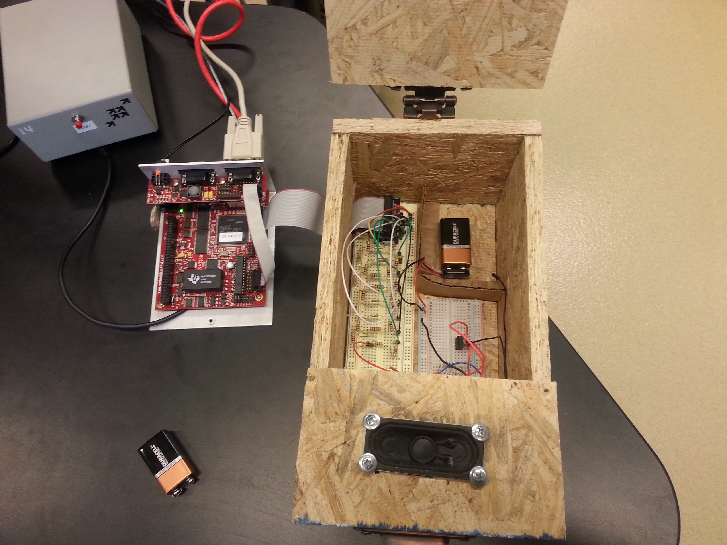
(Speaker module attached to ts7250)

“Song Pro Retro: Light” is used for both demonstrating the speaker modules potential, with a clean output signal, and for demonstrating the use of a single instrument. The program consists of 4 threads. The main thread initializes the program, and requests a song to play. Upon entering an existing song title, a song structure is created, which contains the parameters of the song, and a pointer to the start of the linked list of tones. The structure is then sent to a song initializing thread. The main thread then waits for another song to be entered, or for a “q”, which will exit the program. The song initializing thread reads the basic information from the .sng file, which includes the title of the song, and tempo. The program will then read each tone line from the .sng file, and store them in their respective nodes in the linked list. Upon reaching the end of the file, a function is called, which translates the names of the notes into frequencies, and calculates how long the note should play, based on the type of note, and tempo. The thread then calculates how long the song will play, based on the tempo and the number of beats in the song. The Song Initializer thread then calls the song execution thread, and then completes it’s execution. The song execution thread contains an infinite “While” loop, which repeats once for each tone to be played. On every iteration of the loop, it calls a thread called tone execution, and passes the tone parameters to the thread. It then sleeps for the length of the note being played, and then signals the tone to cease playing. It then loads the next tone and goes back to the top of the loop. The Tone execution thread contains a real time task, which oscillates the Port D value between 0 and the given volume. This oscillation is performed at the rate specified by the song. Upon receiving a signal from the Song execution thread, the tone execution thread will cease to run. The final piece of the program is a memory clearing function, which performs cleanup on the song structure, and tone linked list.

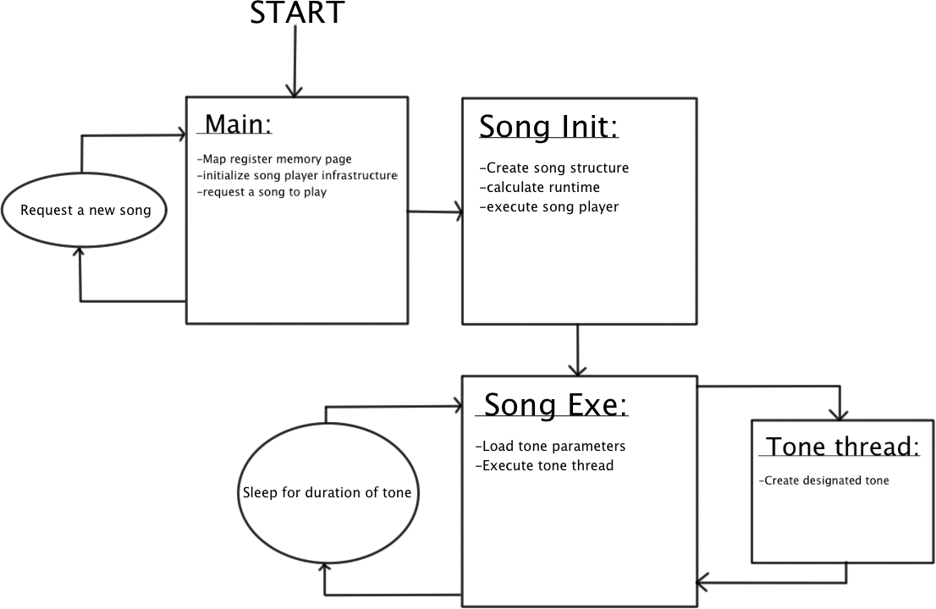
(Song Pro Retro: Light flow diagram)

“Song Pro Retro: Poly” takes the concepts put in place by “Song Pro Retro: Light” and uses them to create multiple instruments at the same time. There are 2 pieces of software that are run for this component. The first is the client program. The client program is essentially “Song Pro Retro: Light” with a few added parts. Instead of having the Tone execution thread write directly to Port D, it instead writes to a global tone buffer. The thread, “Tone Write” reads from the global tone buffer at a fixed sampling rate, and stores these values in a circular buffer with 4,000 nodes. There also exists a thread called “Com Thread Out”, this thread reads from the circular buffer every .5 seconds, and stores 1,000 of the frames into a string message, along with brief header information. This message then gets broadcasted using UDP. In addition to these new threads, there is also another thread, which waits for commands from the server. The first command the server can send is “&START”. The start command tells the client to begin playing the song, this allows all clients to begin at the same time, which helps with keeping all audio streams together. Another command is “&LIST”. The list command has the client send information about the system to the server. This command is useful because it allows the server to count the total number of clients in use. The final command that can be received is “&END”. The end command notifies the client to stop running. This command is useful when you no longer want the song to play. The second part of the “Song Pro Retro: Poly” component, is the server program. The server has a few threads that run. The main thread creates a socket, and initializes the circular Com buffer. The main thread then sets up the Port D memory page, and starts both the Player thread and Com thread. The final task of the main thread is to wait for the user to request for the program to exit, at which point the server will broadcast the command “&END” to the clients. The Com thread starts by sending the “&LIST” command, which asks all of the clients to send their basic information. By doing this, the server knows what to divide the incoming values by, in order to stay within the range of the DAC in the speaker module. The Com thread then broadcasts the “&START” message to the clients, which begins the decoding of each of their individual parts of the song. As messages come in from the clients, the Com thread parses them into individual sub frames, and stores them into the circular buffer. The player thread waits one second for the Com thread to gain a lead in the circular buffer. The thread then proceeds to read the values from each node at a fixed rate of .5 milliseconds per frame. The thread then writes these values to Port D, allowing the speaker module to translate them into sound.

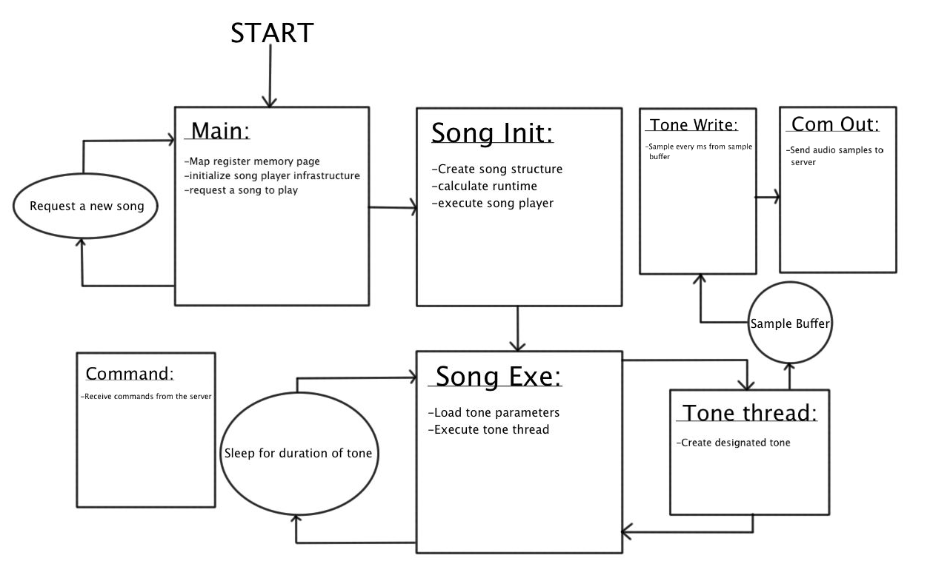
(Song Pro Retro Poly Client flow diagram)

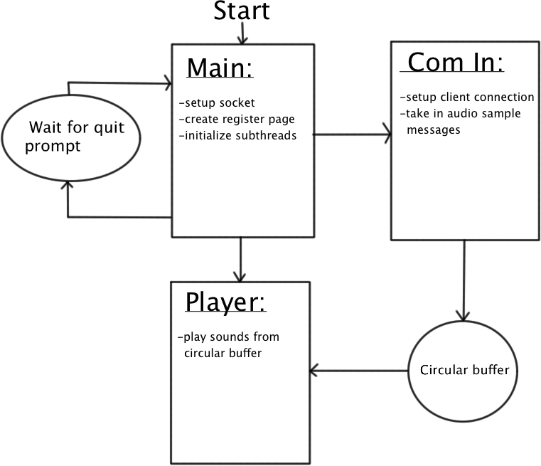
(Song Pro Retro Poly Server flow diagram)

Experiments:

I ran experiments on each of the components of the project. The experiment I ran on the speaker module, involved pushing specific numbers into the DAC, and recording the voltage output of both the DAC and amplifier. The DAC produced a very linear response, while the amplifier generated a linear response, with an initial voltage offset. The results are contained in the figure below:

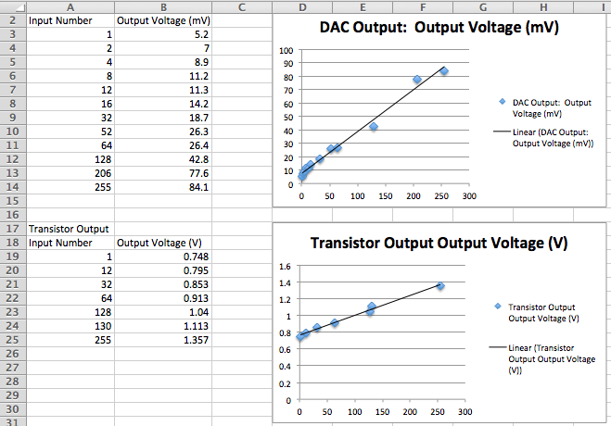
(DAC and amplifier output graphs)

The tests I performed on “Song Pro Retro: Light“ involved adjusting the tempo of the songs, to determine how well the program responds to changes in speed. I found that the application was able to handle all reasonable tempos within the range of songs that would be played. I also adjusted the tone definitions file to accommodate a range of 4 octaves. Due to the speaker in the module assembly allowing for between 100 and 20khz, the hardware is able to play almost any tone needed by the user.

The experiment I used for “Song Pro Retro: Poly” involved adjusting the sampling rate to reduce the resource consumption of the application. I unfortunately was unable to have all tasks I needed to run at the same time, within the periods needed. By having a sampling, tone generation, socket communication, and song execution processes all running at the same time, the board was unable to keep up with the demands of the program. This issue resulted in large gaps between tones being generated by the server. Despite this large issue, the “Song Pro Retro: Light” program was able to run, due to being a much more lightweight program. In addition to the overloading issue of the “Song Pro Retro: Poly” platform, I was also unable to maintain a good sampling rate. In order to allow for clean audio sampling, I would need to take a sample every .1 ms. by having a sample rate of this speed, the TS7250 board doesn’t have enough remaining time to perform the other processes needed to run the system. The inherent multithreaded issues in the “Song Pro Retro: Poly” platform makes the TS7250 not a viable platform to use, due to the single threaded processor on the board. If I instead had a board with 2 cores, I could run both the sampling and tone generation threads in parallel, allowing to somewhat negate the bottleneck effect of the single core.

Discussion:
I found that this project did an excellent job of displaying the skills I learned in the Real Time Embedded Systems course. The topics I used in my project included: R 2R DAC, real time tasks, pthreads, UDL Socket Communication, GIO pin manipulation, circular buffers, and hardware / software integration. I was able to get both the speaker module, and “Song Pro Retro: Light” program working completely. Unfortunately, due to the aforementioned limitations of the “Song Pro Retro: Poly” platform, I was unable to get this system fully functional. The main way in which I could correct the issues pertaining to “Song Pro Retro: Poly”, would be using an embedded system which contains a multicore processor. With a multicore processor, I could split the resource intensive tasks between cores, allowing for a reduced bottlenecking effect. Another way that I could improve the “Song Pro Retro” platform, would be to substitute the transistor amplifier, for a single source opamp circuit. The advantage of the transistor amplifier, vs. a double source opamp circuit, is that the transistor only requires a single 9volt battery. The double source opamp circuit requires 2 9volt batteries, supplying both a positive and negative voltage source. A single source opamp circuit would only require a one 9volt battery. The single source opamp circuit would also supply a more reliable amplification to the speaker, allowing for higher quality audio output.

Code:
Example .sng file:
Little Fugue - Bach
90

//measure 1
G 4 N 8 4
D 5 N 8 4
B 4 F 8 3
A 4 N 8 8

//measure 2
G 4 N 8 8
B 4 F 8 8
A 4 N 8 8
G 4 N 8 8
F 4 S 8 8
A 4 N 8 8
D 4 N 8 4

//measure 3
G 4 N 8 8
D 4 N 8 8
A 4 N 8 8
D 4 N 8 8
B 4 F 8 8
A 4 N 8 16
G 4 N 8 16
A 4 N 8 8
D 4 N 8 8

//measure 4
G 4 N 8 8
D 4 N 8 16
G 4 N 8 16
A 4 N 8 8
D 4 N 8 16
A 4 N 8 16
B 4 F 8 8
A 4 N 8 16
G 4 N 8 16
A 4 N 8 16
D 4 N 8 16
D 5 N 8 16
C 5 N 8 16

//measure 5
B 4 F 8 16
A 4 N 8 16
G 4 N 8 16
B 4 F 8 16
A 4 N 8 16
G 4 N 8 16
F 4 S 8 16
A 4 N 8 16
G 4 N 8 16

NoteConversion.h:
/*
* noteConversion.h
*
* Created on: Apr 22, 2014
* Author: alhhbf
*/

#ifndef Song_Pro_Retro_noteConversion_h
#define Song_Pro_Retro_noteConversion_h
struct tonedef{
char base;
int octave;
char sign;
int volume;
long frequency;
int duration;
long realduration;
int *songFlag;
struct tonedef *next;
};
typedef struct tonedef tone;

struct songdef{
int tempo;
char title[150];
struct tonedef *start;
struct notedef *def;
int length;
FILE *fpsong;
char directory[150];
int songFlag;
double total;
};
typedef struct songdef song;

struct notedef{
char base;
int octave;
char sign;
long frequency;
struct notedef *next;
};
typedef struct notedef definition;

struct buffSub{
int buffID;
int value;
struct buffSub *next;
};
typedef struct buffSub SubFrame;

struct buffFrame{
int buffer[100];
int buffID;
struct buffSub *start;
struct buffFrame *next;
};
typedef struct buffFrame Frame;

char fcheck(FILE *file) {
char c;
c = fgetc(file);
ungetc(c, file);
return c;
}

definition *def;

void defInit(void){
definition *defTemp = malloc(sizeof(definition));
definition *defCurr;
defCurr = defTemp;
FILE *defFile = fopen("definitions.txt", "r");
if( defFile == NULL ){
perror("fopen");
}
//while(EOF != fscanf(defFile, "%c%d%c%ld", &defCurr->base, &defCurr->octave, &defCurr->sign, &defCurr->frequency)){

while(1){
if(feof(defFile)){
break;
}
fscanf(defFile, "%c ", &defCurr->base);
fscanf(defFile, "%d ", &defCurr->octave);
fscanf(defFile, "%c ", &defCurr->sign);
fscanf(defFile, "%ld ", &defCurr->frequency);
definition *temp = malloc(sizeof(definition));
defCurr->next = temp;
defCurr = defCurr->next;
}
//printf("got here!");
//fflush(stdout);
fclose(defFile);
defCurr = defTemp;
/*while(defCurr != NULL){
printf("\nbase: %c\noctave: %d\nsign: %c\nfrequency: %ld\n", defCurr->base, defCurr->octave, defCurr->sign, defCurr->frequency);
defCurr = defCurr->next;
}*/
def = defTemp;
return;
}

void noteconvert(struct songdef *start){
struct tonedef *current;
definition *currDef;
currDef = def;
current = start->start;
int i = 0;
while(current != NULL){
//printf("%c\n", current->base);
//fflush(stdout);
i++;
if(currDef->base == current->base && currDef->octave == current->octave && currDef->sign == current->sign){
current->frequency = currDef->frequency;
//current->songFlag = malloc(sizeof(int));
current->songFlag = &start->songFlag;
//printf("%d\n", *current->songFlag);
//current->frequency = 1000000000 * (1 / ((double)current->frequency));
current->frequency = 8000000 * (1 / ((double)current->frequency / 1000));
//current->frequency = current->frequency * 1000;
current->realduration = 1000000000 * ((60 * 4) / ((double)current->duration * (double)start->tempo));
current = current->next;
currDef = def;
}
else{
currDef = currDef->next;
if(currDef == NULL){
printf("\ntone not defined!\n");
break;
}
}
}
return;
}

#endif

Song Pro Retro: Light:
/*
============================================================================
Name : SongProRetro.c
Author : Alex Harper
Version :
Copyright : Song Pro Retro
Description : Hello World in C, Ansi-style
============================================================================
*/

#include <stdio.h>
#include <stdlib.h>
#include <unistd.h>
#include <pthread.h>
#include <time.h>
#include <string.h>
#include "noteConversion.h"
#include <math.h>
#include <rtai.h>
#include <rtai_lxrt.h>
#include <sys/mman.h>
#include <fcntl.h>
#include <unistd.h>
#define PI 3.14159265

FILE *fpsong;
pthread_t songBoot, songRun, toneRun;
song *songTemp;
volatile int songFlag;
unsigned long *PFDR, *PFDDR, *PBDR, *PBDDR;
unsigned char *start;
RTIME period;

void cls(void){
int printf(char*,...);
printf("%c[2J",27);
}
void songClear(song *songa){
//clean up the memory used by the song structure
tone *current;
int j, k;
int i = songa->length;
while(1){
k = 0;
current = songa->start;
if(i > 0){
for(j = 0; j < i; j++){
current = current->next;
}
free(current);
i--;
}
if(i == 0){
free(songa);
break;
}
}
return;
}

void *toneExe(void *ptr){
//generate the played on the speaker
tone *tonea;
tonea = (tone*)ptr;
int i;
RT_TASK* rttasktone = rt_task_init(nam2num("tone"), 1, 512, 256);
rt_task_make_periodic(rttasktone, rt_get_time(), (tonea->frequency / 500)*period);
i = 0;
while(*tonea->songFlag != 1 && songFlag == 0){
*PBDR |= tonea->volume;
rt_task_wait_period();
*PBDR &= 0x00;
rt_task_wait_period();
}
*PBDR &= 0x00;
pthread_exit(0);
}

void *songExe(void *ptr){
tone *toneTemp;
song *songa;
long duration;
songa = (song*)ptr;
toneTemp = songa->start;

//loads a tone, and runs it in the toneExe thread, until the duration completes
while(toneTemp != NULL && songFlag == 0){
songa->songFlag = 0;
duration = toneTemp->realduration;
pthread_create(&toneRun, NULL, (void *) &toneExe, (void *)toneTemp);
toneTemp = toneTemp->next;
usleep((unsigned)duration / 1000);
songa->songFlag = 1;
usleep(1000);
pthread_kill(toneRun, 0);
pthread_join(toneRun, NULL);
}
*PBDR &= 0x00;
songClear(songa);
pthread_exit(0);
}

void *songInit(void *ptr){
char temp[14];
char tempDur[2];
char *cpoint;
int songHour, songMin, songSec;
double songBreak;
float songRatio;
song *songa;
songa = (song*)ptr;
songa->fpsong = fopen(songa->directory, "r");
if(songa->fpsong == NULL){
printf("Could not load file!\n");
pthread_exit(0);
}

//obtain song info from file header
fgets(songa->title, sizeof(songa->title), songa->fpsong);
fscanf(songa->fpsong, "%d", &songa->tempo);
printf("\n%s", songa->title);
printf("Tempo: %d\n", songa->tempo);

tone *currenta = malloc(sizeof(tone));
songa->start = currenta;

//burn first unused line
fgets(temp, sizeof(temp), songa->fpsong);
songa->length = 0;
songa->total = 0;
//pull info from .sng file and store in linked list
while(1){
//obtain info and parse into each datum
while(1){
fgets(temp, sizeof(temp), songa->fpsong);
if(temp[0] != '\n' && temp[0] != '/'){
break;
}
}
currenta->base = temp[0];
cpoint = &temp[2];
currenta->octave = atoi(cpoint);
currenta->sign = temp[4];
cpoint = &temp[6];
currenta->volume = 25 * atoi(cpoint);
tempDur[0] = temp[8];
tempDur[1] = temp[9];
currenta->duration = atoi(tempDur);
songa->total += (1/((float)currenta->duration));
currenta->next = NULL;
songa->length++;
if(feof(songa->fpsong)){
break;
}
tone *temp = malloc(sizeof(tone));
currenta->next = temp;
currenta = temp;
}
fclose(songa->fpsong);
currenta = songa->start;
noteconvert(songa);

//calculate the runtime for the song, and print it to the screen
songa->total = songa->total * 4;
songBreak = (60 / (double)songa->tempo) * (double)songa->total;
songSec = songBreak;
while(1){
if(songSec < 60)
break;
else{
songSec = songSec - 60;
}
}
songMin = songBreak / 60;
songHour = songBreak / 3600;
printf("Time: %d:%d:%d\n", songHour, songMin, songSec);
fflush(stdout);
pthread_create(&songRun, NULL, (void *) &songExe, (void *)songTemp);
pthread_exit(0);
}

int main(void)
{
cls();
char directory[150];
int i;

//initialize port F
int fd = open("/dev/mem", O_RDWR | O_SYNC);
start = (unsigned char*)mmap(NULL, getpagesize(), PROT_READ|PROT_WRITE, MAP_SHARED, fd, 0x80840000);
PFDR = (unsigned long*)((unsigned char*)start + 0x30);
PFDDR = (unsigned long*)((unsigned char*)start + 0x34);
PBDR = (unsigned long*)((unsigned char*)start + 0x04);
PBDDR = (unsigned long*)((unsigned char*)start + 0x14);
*PBDDR |= 0xFF;
*PFDDR |= 0x02;
period = start_rt_timer(nano2count(100000));
defInit();
//select a song
while(1){
song *songa;
printf("Enter a song path (or 'q' to quit): ");
fflush(stdout);
scanf("%s", directory);
songFlag = 1;
usleep(10000);
pthread_kill(songBoot, 0);
pthread_kill(songRun, 0);
pthread_kill(toneRun, 0);
if(directory[0] == 'q' && directory[1] == '\0'){
return 0;
}
else{
songFlag = 0;
songa = malloc(sizeof(song));
for(i = 0; i < 150; i++){
songa->directory[i] = directory[i];
}
songTemp = songa;
cls();
pthread_create(&songBoot, NULL, (void *) &songInit, (void *)songa);
usleep(500000);
}
}
return 0;
}

Song Pro Retro: Poly Client:
/*
============================================================================
Name : SongProRetro.c
Author : Alex Harper
Version :
Copyright : Song Pro Retro
Description : Hello World in C, Ansi-style
============================================================================
*/

#include <stdio.h>
#include <stdlib.h>
#include <unistd.h>
#include <pthread.h>
#include <time.h>
#include <string.h>
#include "noteConversion.h"
#include <math.h>
#include <rtai.h>
#include <rtai_lxrt.h>
#include <sys/mman.h>
#include <fcntl.h>
#include <unistd.h>
#include <sys/types.h>
#include <sys/socket.h>
#include <netinet/in.h>
#include <arpa/inet.h>
#include <netdb.h>

#define PI 3.14159265
#define comSize 15050

FILE *fpsong;
pthread_t songBoot, songRun, toneRun, comCommand, comOut, toneWriteThread;
song *songTemp;
char title[150];
unsigned long *PFDR, *PFDDR, *PBDR, *PBDDR;
unsigned char *start;
RTIME period;

struct sockaddr_in anybody, from;
struct hostent *hp;
char comBufferCommand[comSize];
char comBufferFrame[comSize];
long valBuffer;
char boardIP[15];
char *boardID;
int len, sockID, n;
char host[64];
int boolval;

Frame *writeFrame;

//global flags
volatile int songFlag, startFlag, endFlag;

void cls(void){
int printf(char*,...);
printf("%c[2J",27);
}

void songClear(song *songa){
tone *current;
int j, k;
int i = songa->length;
while(1){
k = 0;
current = songa->start;
if(i > 0){
for(j = 0; j < i; j++){
current = current->next;
}
free(current);
i--;
}
if(i == 0){
free(songa);
break;
}
}
return;
}

void *comThreadCommand(void *ptr){
while(1){
bzero(&comBufferCommand, comSize);
//printf("Before received Data. \n");
//recvfrom(sockID, comBufferCommand, comSize, 0, (struct sockaddr *)&anybody, &len);
anybody.sin_addr.s_addr = inet_addr("10.3.52.255");
strcpy(comBufferCommand, "HEY!");
n = sendto(sockID, comBufferCommand, sizeof(comBufferCommand), 0, (struct sockaddr *)&anybody, len);
printf("%d\n", n);
recvfrom(sockID, comBufferCommand, comSize, 0, (struct sockaddr *)&from, &len);
//printf("%s", comBufferCommand);
if(strcmp(comBufferCommand, "&LIST") == 0){
sprintf(comBufferCommand, "#~%s", boardID);
n = sendto(sockID, comBufferCommand, sizeof(comBufferCommand), 0, (struct sockaddr *)&anybody, len);
if(n == -1){
printf("Error Number: %d\n", n);
}
//printf("%s", comBufferCommand);
}
else if(strcmp(comBufferCommand, "&START") == 0){
//printf("Got here!");
//fflush(stdout);
startFlag = 0;
}
else if(strcmp(comBufferCommand, "&END") == 0){
endFlag = 0;
exit(0);
}
//sleep(1);
//startFlag = 0;
}
pthread_exit(0);
}

void *comThreadOut(void *ptr){
SubFrame *currFrame;
currFrame = (SubFrame*)ptr;
int i;
int j = 0;
//wait for signal to start generating socket messages to send to the server
while(startFlag != 0){
i = 0;
}
RT_TASK* communeOut = rt_task_init(nam2num("comm"), 0, 512, 256);
rt_task_make_periodic(communeOut, (rt_get_time() + 1000 * period), (5000 * period));
while(endFlag != 0){
bzero(&comBufferFrame, comSize);
sprintf(comBufferFrame, "@~%d~%s", j, boardID);
for(i = 0; i < 1000; i++){
//printf("COM Thread Buff ID: %d\n", currFrame->buffID);
//fflush(stdout);
//generate the message containing samples chained together
sprintf(comBufferFrame, "%s~%d", comBufferFrame, currFrame->value);
currFrame = currFrame->next;
rt_sleep(2 * period);
}
n = sendto(sockID, comBufferFrame, sizeof(comBufferFrame), 0, (struct sockaddr *)&anybody, len);
printf("%s\n", comBufferFrame);
j++;
rt_task_wait_period();
}
pthread_exit(0);
}

void *toneWrite(void *ptr){
SubFrame *currFrame;
currFrame = (SubFrame*)ptr;
int i;
//wait for song start signal to begin sampling sound from song
while(startFlag != 0){
i = 0;
}
RT_TASK* toneWr = rt_task_init(nam2num("toneWr"), 0, 512, 256);
rt_task_make_periodic(toneWr, rt_get_time(), (5 * period));
//sample audio and pass it to the sample buffer
while(endFlag != 0){
//printf("WRITE Thread Buff ID: %d\n", currFrame->buffID);
//fflush(stdout);
currFrame->value = valBuffer;
currFrame = currFrame->next;
rt_task_wait_period();
}
pthread_exit(0);
}

void *toneExe(void *ptr){
tone *tonea;
tonea = (tone*)ptr;
int i;
RT_TASK* rttasktone = rt_task_init(nam2num("tone"), 0, 512, 256);
rt_task_make_periodic(rttasktone, rt_get_time(), (tonea->frequency / 2000)*period);
i = 0;

//generate tone at specified frequency
while(*tonea->songFlag != 1 && songFlag == 0){
valBuffer = tonea->volume;
rt_task_wait_period();
valBuffer = 0x00;
rt_task_wait_period();
}
pthread_exit(0);
}

void *songExe(void *ptr){
tone *toneTemp;
song *songa;
long duration;
songa = (song*)ptr;
toneTemp = songa->start;
int i;
int j = 0;
//wait for signal to start song
while(startFlag != 0){
i = 0;
}
RT_TASK* rttaskSong = rt_task_init(nam2num("song"), 1, 512, 256);
rt_task_make_periodic(rttaskSong, rt_get_time(), 1000000*period);
while(toneTemp != NULL && songFlag == 0){
j++;
songa->songFlag = 0;
duration = toneTemp->realduration;
//start a tone generation thread
pthread_create(&toneRun, NULL, (void *) &toneExe, (void *)toneTemp);
toneTemp = toneTemp->next;
//let tone generation thread run for specified duration, then signal it to stop
rt_sleep(nano2count((unsigned)duration));
songa->songFlag = 1;
//pthread_kill(toneRun, 0);
pthread_join(toneRun, NULL);
}
exit(0);
songClear(songa);
pthread_exit(0);
}

void *songInit(void *ptr){
char temp[14];
char tempDur[2];
char *cpoint;
int songHour, songMin, songSec;
double songBreak;
int i;
float songRatio;
song *songa;
songa = (song*)ptr;
songa->fpsong = fopen(songa->directory, "r");
if(songa->fpsong == NULL){
printf("Could not load file!\n");
pthread_exit(0);
}

//obtain song info from file header
fgets(songa->title, sizeof(songa->title), songa->fpsong);
fscanf(songa->fpsong, "%d", &songa->tempo);
strcpy(title, songa->title);
printf("\n%s", songa->title);
printf("Tempo: %d\n", songa->tempo);

tone *currenta = malloc(sizeof(tone));
songa->start = currenta;

//burn first unused line
fgets(temp, sizeof(temp), songa->fpsong);
songa->length = 0;
songa->total = 0;
//pull info from .sng file and store in linked list
while(1){

//obtain info and parse into each datum
while(1){
fgets(temp, sizeof(temp), songa->fpsong);
if(temp[0] != '\n' && temp[0] != '/'){
break;
}
}
currenta->base = temp[0];
cpoint = &temp[2];
currenta->octave = atoi(cpoint);
currenta->sign = temp[4];
cpoint = &temp[6];
currenta->volume = 25 * atoi(cpoint);
printf("%d\n", currenta->volume);
tempDur[0] = temp[8];
tempDur[1] = temp[9];
currenta->duration = atoi(tempDur);
songa->total += (1/((float)currenta->duration));
currenta->next = NULL;
songa->length++;
if(feof(songa->fpsong)){
break;
}
tone *temp = malloc(sizeof(tone));
currenta->next = temp;
currenta = temp;
}
fclose(songa->fpsong);
currenta = songa->start;

//convert written notes into frequencies
noteconvert(songa);

//determine the length of the song
songa->total = songa->total * 4;
songBreak = (60 / (double)songa->tempo) * (double)songa->total;
printf("\n%lf\n",songBreak);
songSec = songBreak;
while(1){
if(songSec < 60)
break;
else{
songSec = songSec - 60;
}
}
songMin = songBreak / 60;
songHour = songBreak / 3600;
printf("Time: %d:%d:%d\n", songHour, songMin, songSec);
fflush(stdout);

//initialize the command thread and song execution thread
pthread_create(&comCommand, NULL, (void *) &comThreadCommand, NULL);
pthread_create(&songRun, NULL, (void *) &songExe, (void *)songTemp);
pthread_exit(0);
}

int main(int argc, char *argv[])
{
startFlag = 1;
endFlag = 1;

//obtain the port to use
if(argc < 2){
printf("Not a real port");
return 0;
}
cls();
char directory[150];
int i, j;
char IPTemp[15];

SubFrame *temp;
SubFrame *FrameStart;

//initialize circular comBuffer
for(i = 0; i < 4000; i++){
if(i == 0){
temp = malloc(sizeof(SubFrame));
FrameStart = temp;
}
temp->buffID = i;
//printf("ID: %d", temp->buffID);
//fflush(stdout);
if(i < 3999){
temp->next = malloc(sizeof(SubFrame));
temp = temp->next;
}
else if(i == 3999){
temp->next = FrameStart;
}
}
printf("Finished buffer setup\n");

//initialize the socket
boolval = 1;
sockID = socket(AF_INET, SOCK_DGRAM, 0);

//get IP address
len = sizeof(struct sockaddr_in);
gethostname(host, 64);
hp = gethostbyname(host);
strcpy(boardIP, inet_ntoa(*((struct in_addr *)hp->h_addr)));
printf("\nIP address: %s\n", boardIP);
fflush(stdout);

anybody.sin_family = AF_INET;
anybody.sin_port = htons(atoi(argv[1]));
//anybody.sin_addr.s_addr = htonl(INADDR_ANY);
memcpy((void *)&anybody.sin_addr, hp->h_addr_list[0], hp->h_length);

//bind(sockID, (struct sockaddr *)&anybody, len);
if(setsockopt(sockID, SOL_SOCKET, SO_BROADCAST, &boolval, sizeof(boolval)) < 0){
printf("Error occured when setting socket to broadcast!\n");
exit(-1);
}

//obtain the board number from IP address
strcpy(IPTemp, boardIP);
boardID = strtok(IPTemp, ".");
boardID = strtok(NULL, ".");
boardID = strtok(NULL, ".");
boardID = strtok(NULL, ".");

//initialize Register memory page
fflush(stdout);
int fd = open("/dev/mem", O_RDWR | O_SYNC);
start = (unsigned char*)mmap(NULL, getpagesize(), PROT_READ|PROT_WRITE, MAP_SHARED, fd, 0x80840000);
PBDR = (unsigned long*)((unsigned char*)start + 0x04);
PBDDR = (unsigned long*)((unsigned char*)start + 0x14);
*PBDDR |= 0xFF;

//set the period
period = start_rt_timer(nano2count(100000));

//generate tone definitions
defInit();

//select a song
while(1){
song *songa;
printf("Enter a song path (or 'q' to quit): ");
fflush(stdout);
scanf("%s", directory);
songFlag = 1;
usleep(10000);
pthread_kill(songBoot, 0);
pthread_kill(songRun, 0);
pthread_kill(toneRun, 0);
if(directory[0] == 'q' && directory[1] == '\0'){
return 0;
}
else{
songFlag = 0;
songa = malloc(sizeof(song));
for(i = 0; i < 150; i++){
songa->directory[i] = directory[i];
}
songTemp = songa;
cls();
pthread_create(&songBoot, NULL, (void *) &songInit, (void *)songa);
pthread_create(&toneWriteThread, NULL, (void *) &toneWrite, (void *)FrameStart);
pthread_create(&comOut, NULL, (void *) &comThreadOut, (void *)FrameStart);
usleep(500000);
}
}
return 0;
}

Song Pro Retro: Poly Server:
/*
============================================================================
Name : SongProRetroServer.c
Author : Alex Harper
Version :
Copyright : SongProRetroServer
Description : Hello World in C, Ansi-style
============================================================================
*/

#include <stdio.h>
#include <stdlib.h>
#include <unistd.h>
#include <pthread.h>
#include <time.h>
#include <string.h>
#include "noteConversion.h"
#include <math.h>
#include <rtai.h>
#include <rtai_lxrt.h>
#include <sys/mman.h>
#include <fcntl.h>
#include <unistd.h>
#include <sys/types.h>
#include <sys/socket.h>
#include <netinet/in.h>
#include <arpa/inet.h>
#include <netdb.h>

#define comSize 15050
pthread_t player, com;
RTIME period;

int sockID, n;
socklen_t len;
int flag;
char buff[comSize];
char boardIP[15];
char IPTemp[15];
char host[64];
char *boardID, *valIn;
int frameNum;
int startFlag;
int listFlag;
int numClients;

//socket variables
socklen_t fromLen;
struct sockaddr_in server;
struct sockaddr_in address;

//Pin Port variables
unsigned long *PBDR, *PBDDR;
unsigned char *start;

void *comIn(void *ptr){
SubFrame *currFrame;
currFrame = (SubFrame*)ptr;
SubFrame *temp = currFrame;
frameNum = 0;

int oldFrame;
int i;
n = recvfrom(sockID, buff, comSize, 0, (struct sockaddr *)&address, &fromLen);

if(numClients == 0){
printf("No Clients Available!!!\n");
fflush(stdout);
exit(0);
}

printf("Starting in:\n");
fflush(stdout);
printf("...3\n");
fflush(stdout);
sleep(1);
printf("...2\n");
fflush(stdout);
sleep(1);
printf("...1!\n");
fflush(stdout);
sleep(1);
bzero(&buff, comSize);
strcpy(buff, "&START");
address.sin_addr.s_addr = inet_addr("10.3.52.255");
n = sendto(sockID, buff, comSize, 0, (struct sockaddr *)&address, fromLen);
if(n == -1){
printf("Error Number: %d\n", n);
}

printf("Starting task!\n");
fflush(stdout);
RT_TASK* communeIn = rt_task_init(nam2num("comm"), 0, 512, 256);
rt_task_make_periodic(communeIn, rt_get_time(), (2000 * period));
while(1){
while(1){
bzero(&buff, comSize);
n = recvfrom(sockID, buff, comSize, 0, (struct sockaddr *)&address, &fromLen);
if(buff[0] == '@')
break;
}
valIn = strtok(buff, "~");
frameNum = atoi(strtok(NULL, "~"));
if(frameNum >= oldFrame){
if(frameNum > oldFrame){
oldFrame = frameNum;
}
if(frameNum == oldFrame){
currFrame = temp;
}
valIn = strtok(NULL, "~");
temp = currFrame;
for(i = 0; i < 500; i++){
currFrame->value = (atoi(strtok(NULL, "~")) / numClients);
currFrame = currFrame->next;
rt_sleep(2 * period);
}
}
rt_task_wait_period();
}
pthread_exit(0);
}

void *playerOut(void *ptr){
SubFrame *currFrame;
currFrame = (SubFrame*)ptr;
printf("Before Player Task!\n");
RT_TASK* playOut = rt_task_init(nam2num("player"), 0, 512, 256);
rt_task_make_periodic(playOut, (rt_get_time() + (1000 * period)), (5 * period));
while(1){
if(frameNum > 0){
*PBDR = currFrame->value;
currFrame = currFrame->next;
}
rt_task_wait_period();
}
pthread_exit(0);
}

int main(int argc, char *argv[]) {
//enter a port
if(argc < 2){
printf("Not a real port");
return 0;
}
//initialize values of variables
int i, j;
flag = 1;
startFlag = 0;
listFlag = 1;
char trigger = 'x';

//initialize the socket
sockID = socket(AF_INET, SOCK_DGRAM, 0);
len = sizeof(struct sockaddr_in);

//clear the buffer
bzero(&server, len);

//setup the port information
server.sin_family = AF_INET;
server.sin_addr.s_addr = htonl(INADDR_ANY);
server.sin_port = htons(atoi(argv[1]));

//bind the socket
bind(sockID, (struct sockaddr *)&server, len);
setsockopt(sockID, SOL_SOCKET, SO_BROADCAST, &flag, sizeof(flag));
fromLen = sizeof(struct sockaddr_in);

//determine the IP address of the system
gethostname(host, 64);
struct hostent *p = gethostbyname(host);
strcpy(boardIP, inet_ntoa(*((struct in_addr *)p->h_addr)));
printf("\nIP address: %s\n", boardIP);
fflush(stdout);

//obtain board number
strcpy(IPTemp, boardIP);
boardID = strtok(IPTemp, ".");
boardID = strtok(NULL, ".");
boardID = strtok(NULL, ".");
boardID = strtok(NULL, ".");

SubFrame *temp;
SubFrame *FrameStart;
for(i = 0; i < 4000; i++){
if(i == 0){
temp = malloc(sizeof(SubFrame));
FrameStart = temp;
}
temp->buffID = i;
if(i < 3999){
temp->next = malloc(sizeof(SubFrame));
temp = temp->next;
}
else if(i == 3999){
temp->next = FrameStart;
}
}

//setup the pin port registers
int fd = open("/dev/mem", O_RDWR | O_SYNC);
start = (unsigned char*)mmap(NULL, getpagesize(), PROT_READ|PROT_WRITE, MAP_SHARED, fd, 0x80840000);
PBDR = (unsigned long*)((unsigned char*)start + 0x04);
PBDDR = (unsigned long*)((unsigned char*)start + 0x14);
*PBDDR |= 0xFF;

period = start_rt_timer(nano2count(100000));

printf("How many clients: ");
scanf("%d", &numClients);

pthread_create(&com, NULL, (void *) &comIn, (void *)FrameStart);
printf("Initialized com thread\n");
fflush(stdout);
pthread_create(&player, NULL, (void *) &playerOut, (void *)FrameStart);
printf("Initialized player thread\n");
fflush(stdout);

//main loop
while(1){
printf("Enter q to exit: ");
scanf("%c", &trigger);
if(trigger == 'q')
break;
}
return EXIT_SUCCESS;
}

